**0. All the unit tests and integration tests passing**

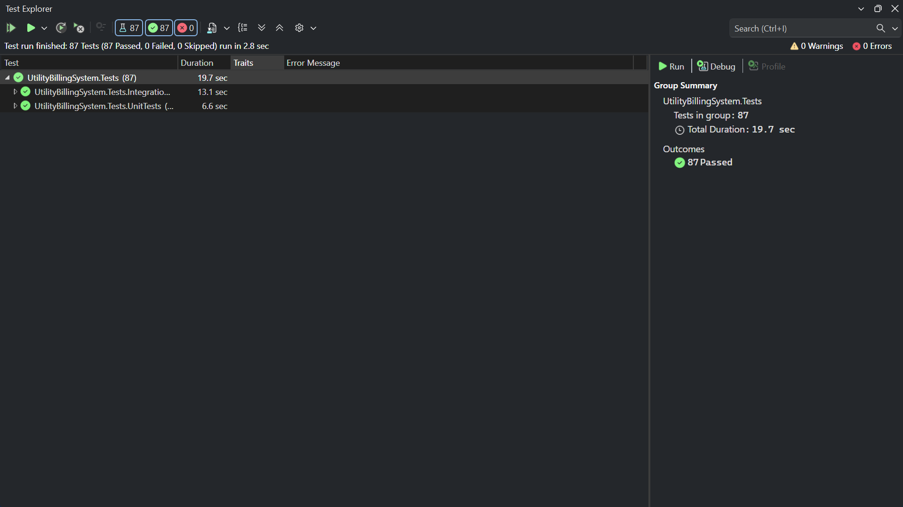

**1. Register Screen**

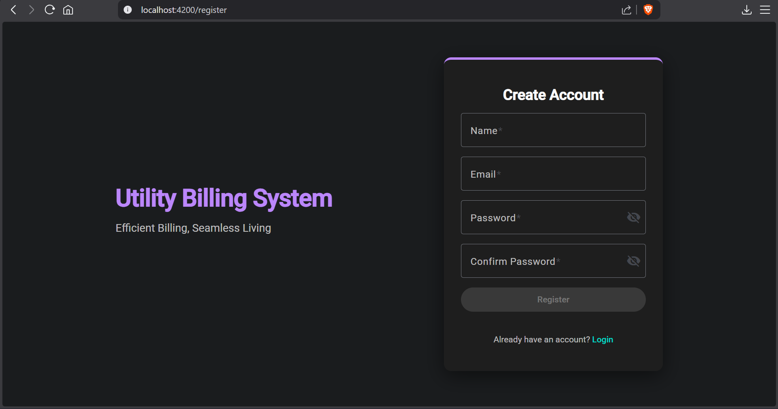

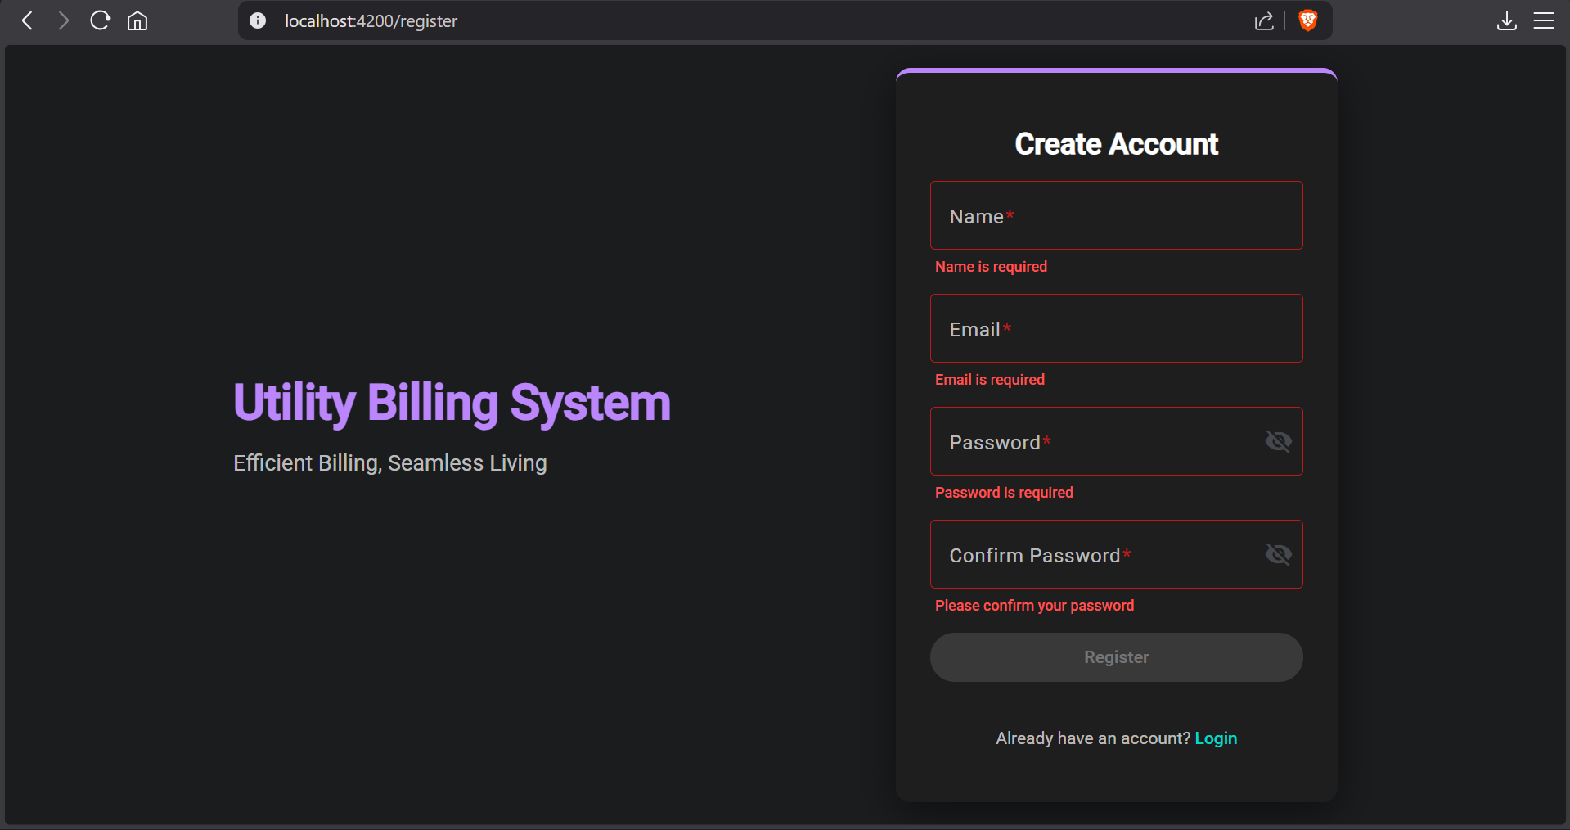

**2. Login Screen**

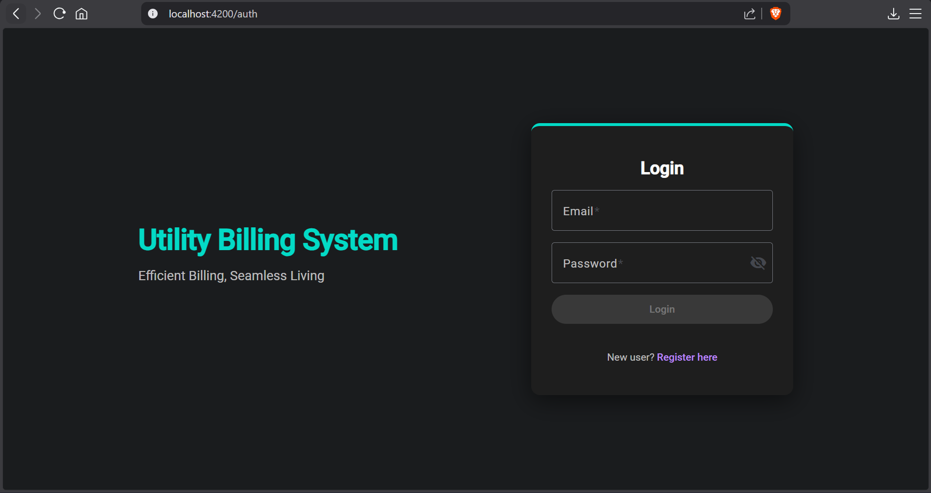

**Admin**

**3. Admin Dashboard**

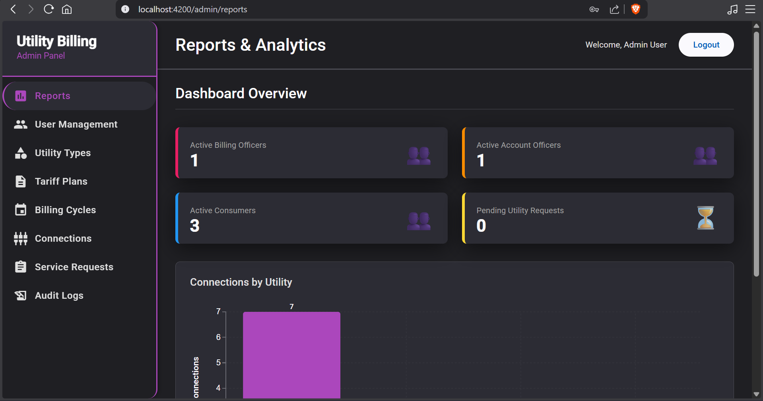

**4. Admin - User management**

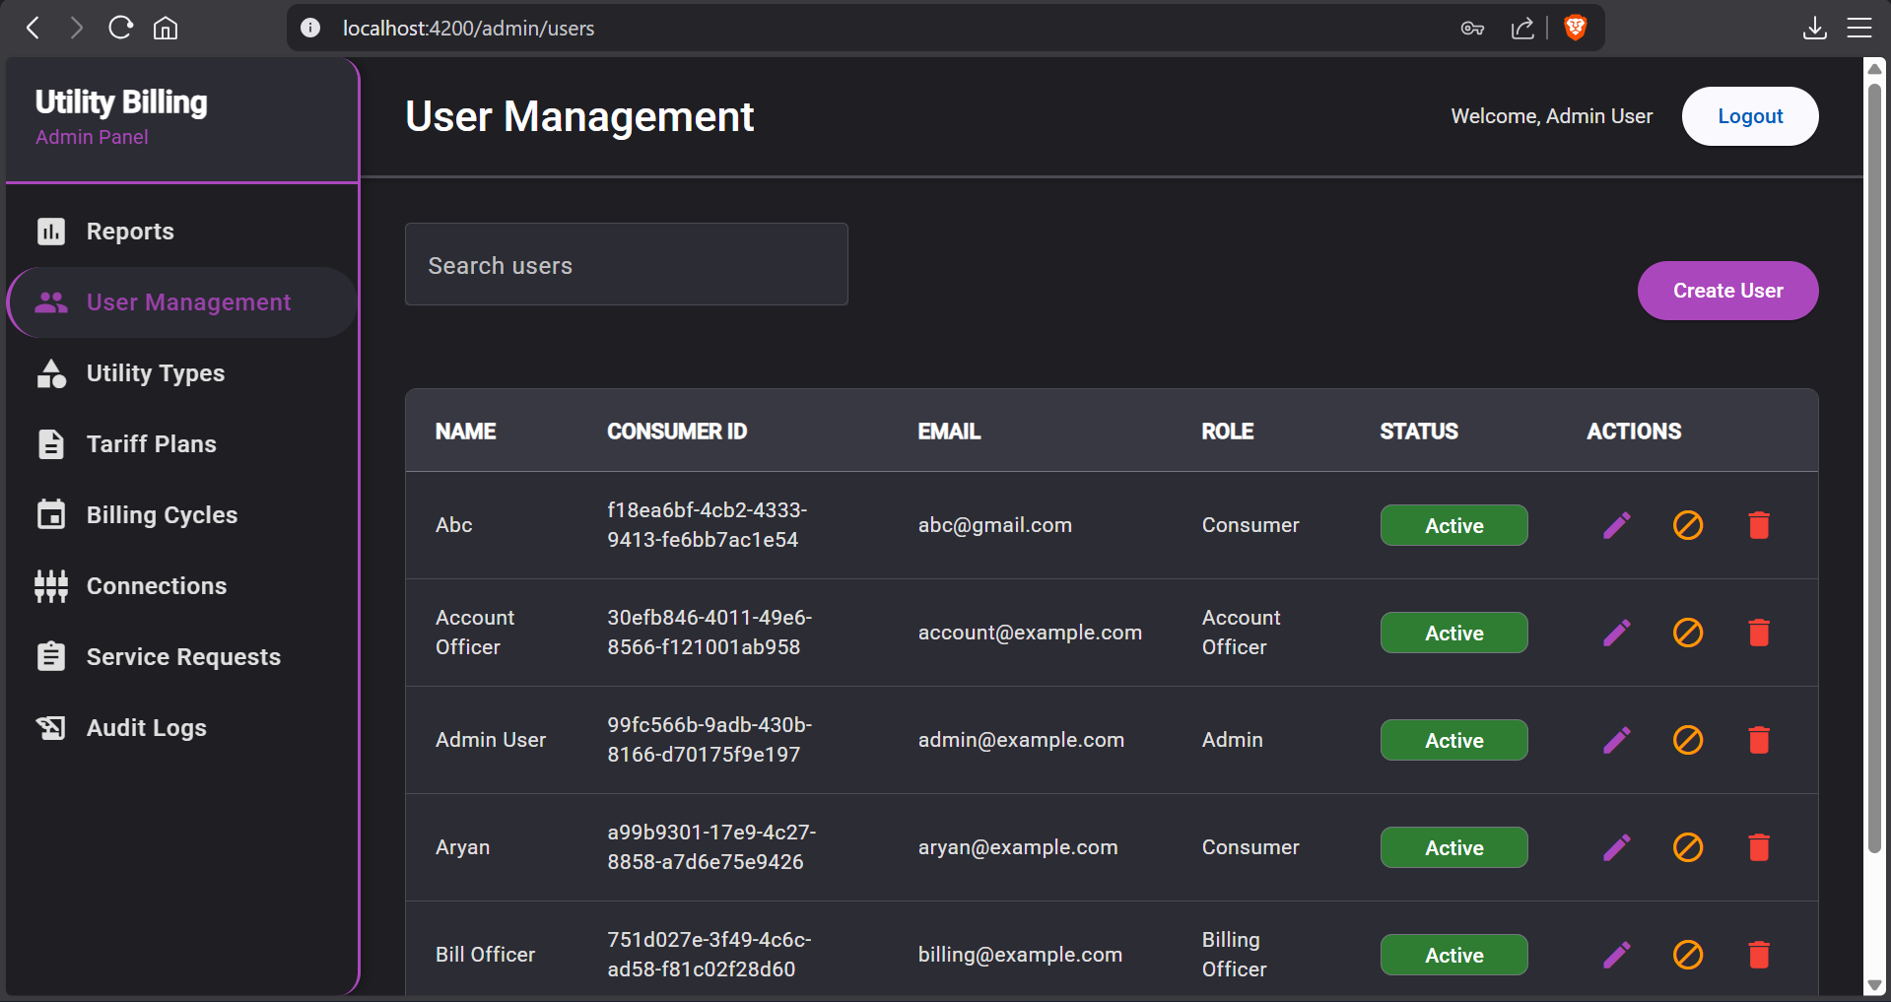

**5. Admin - Utility Types**

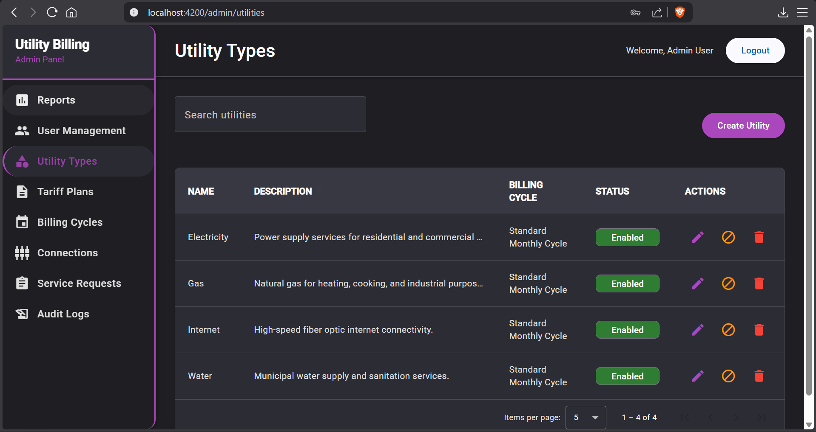

**6. Admin - Tariff Plans**

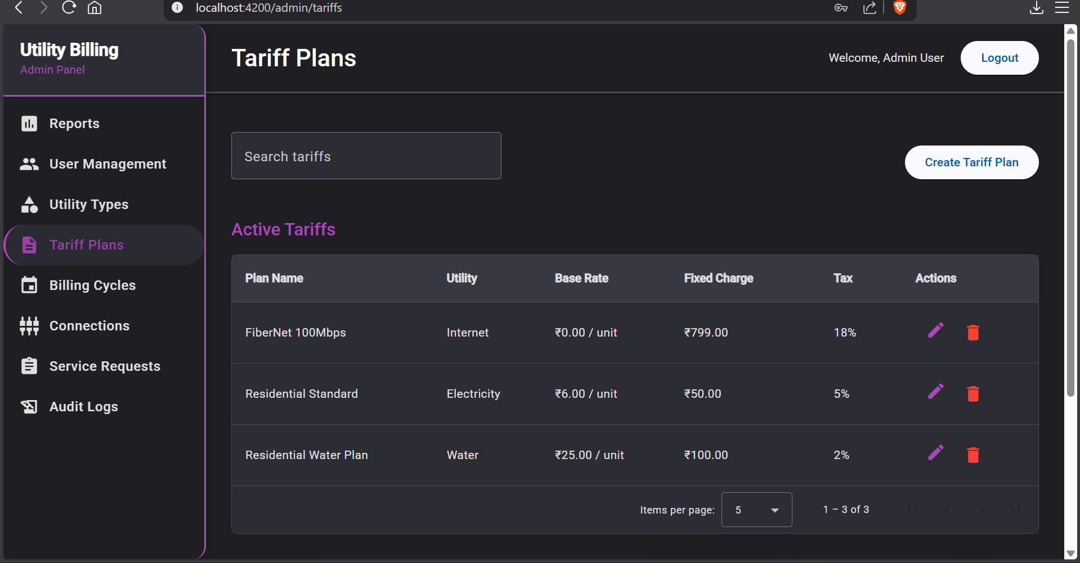

**7. Admin - Billing Cycles**

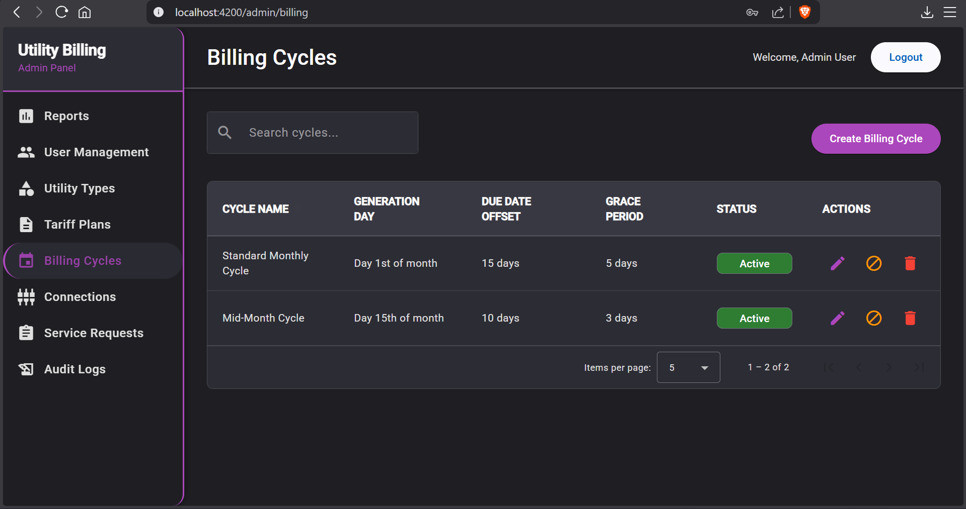

**8. Admin - Connections**

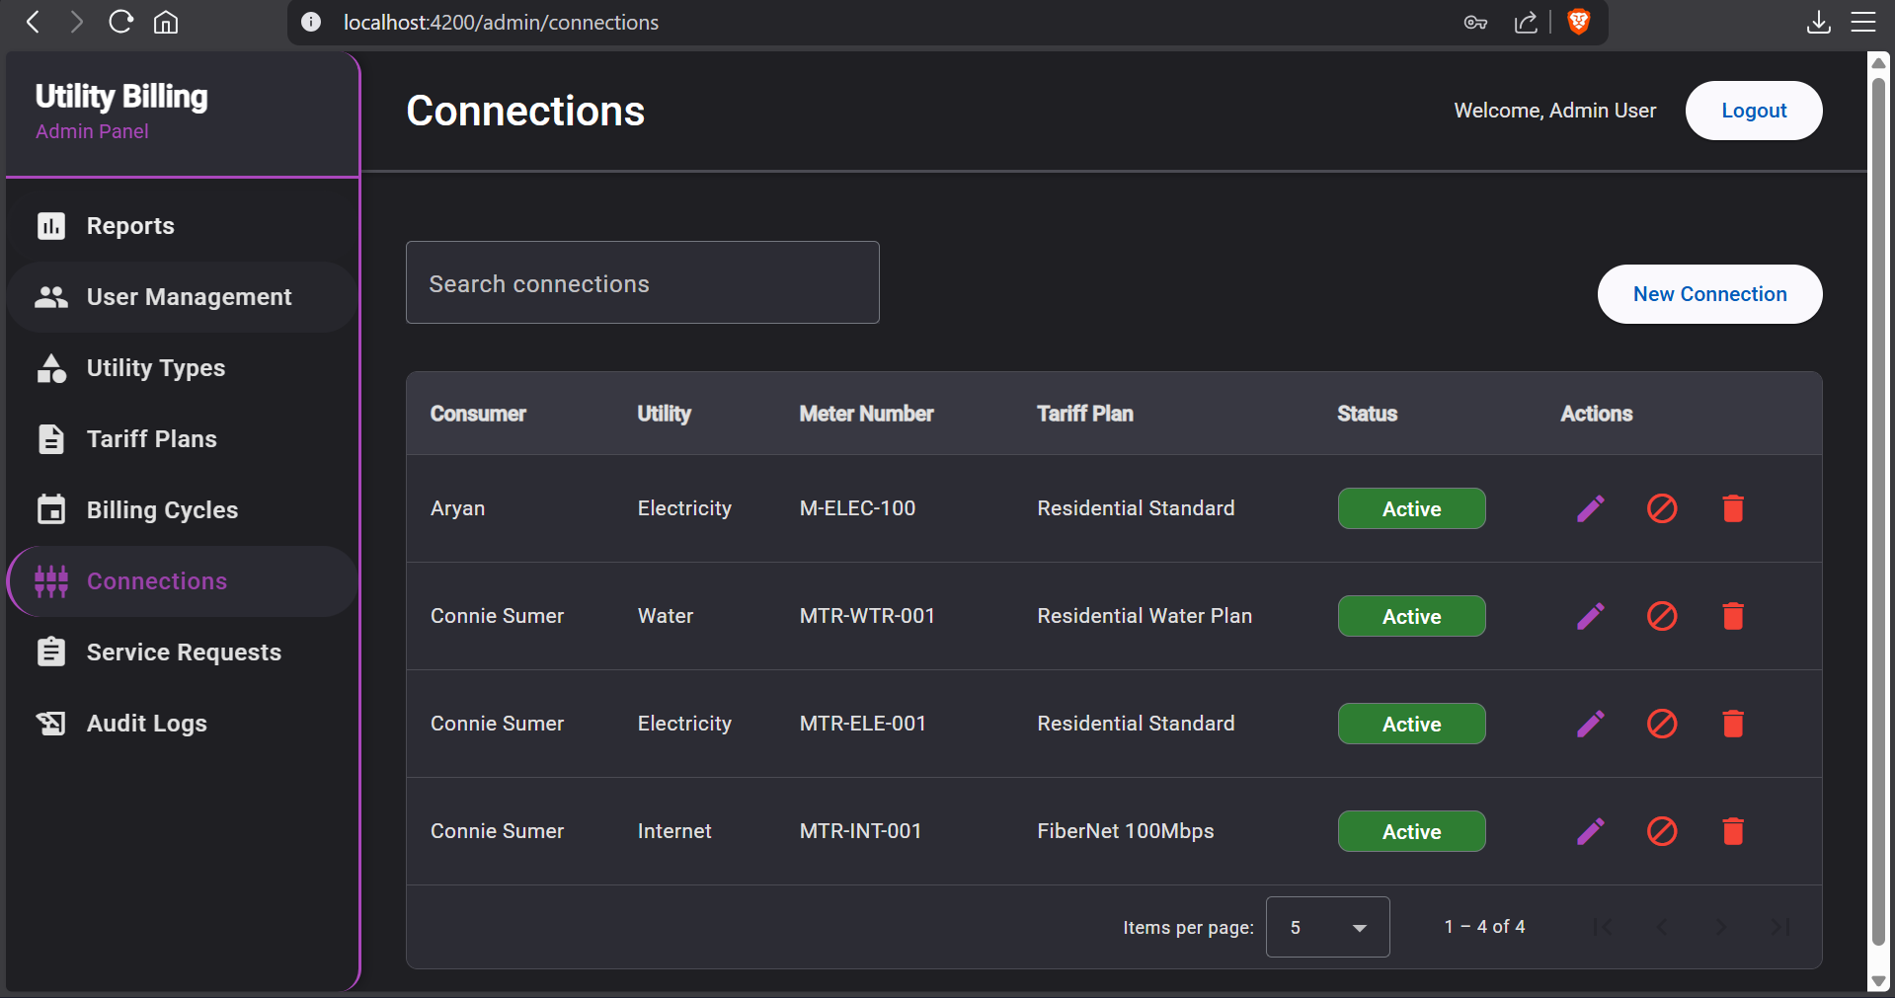

**9. Admin - Service Requests**

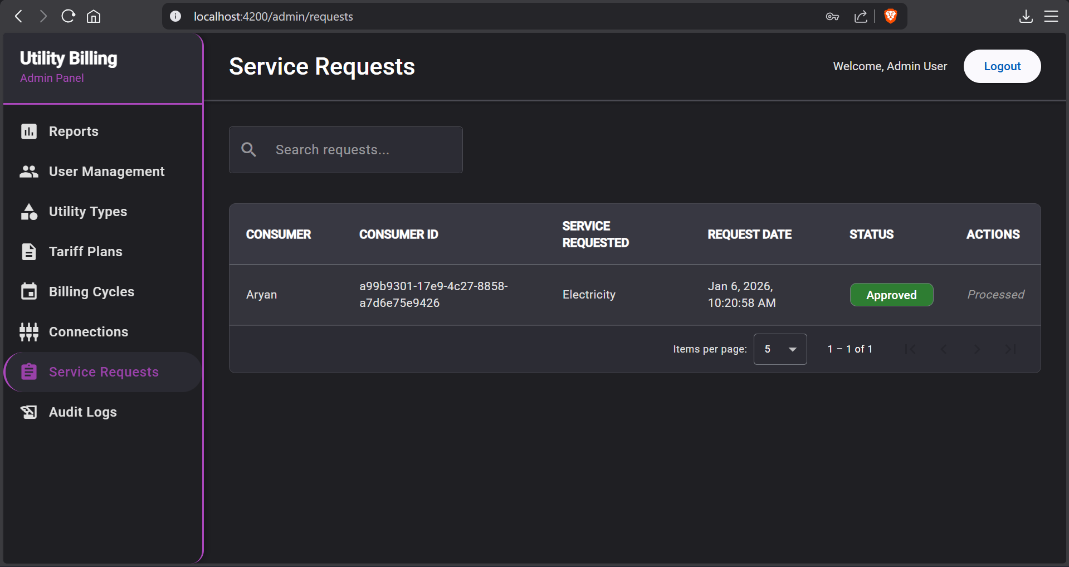

**10. Admin – Audit Log**

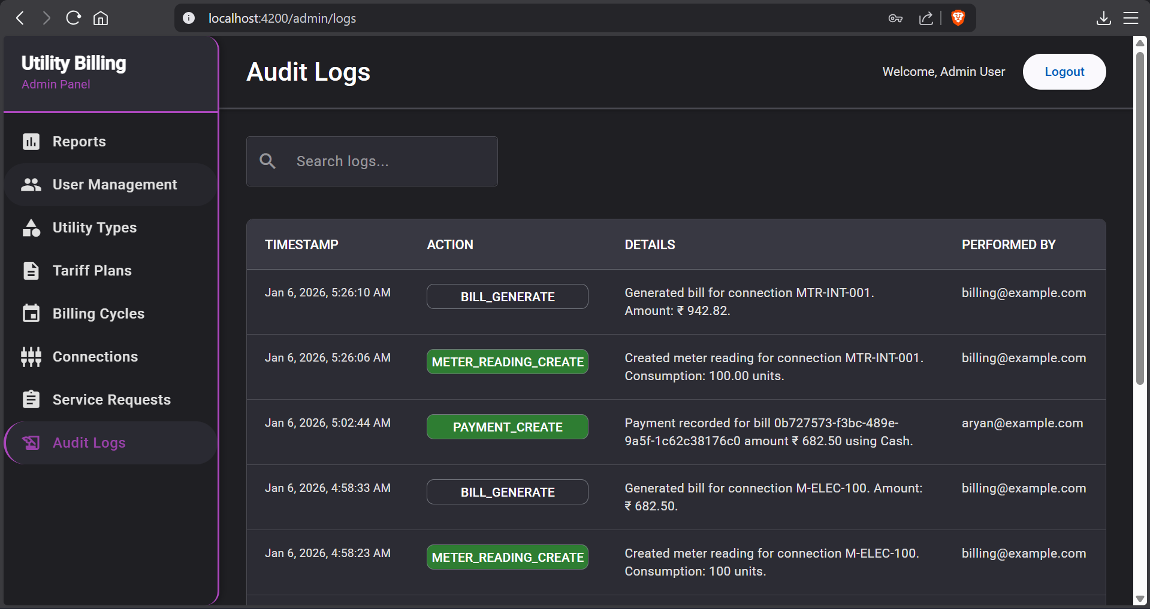

**11. Admin – Error message when admin tries to delete user with unpaid bills**

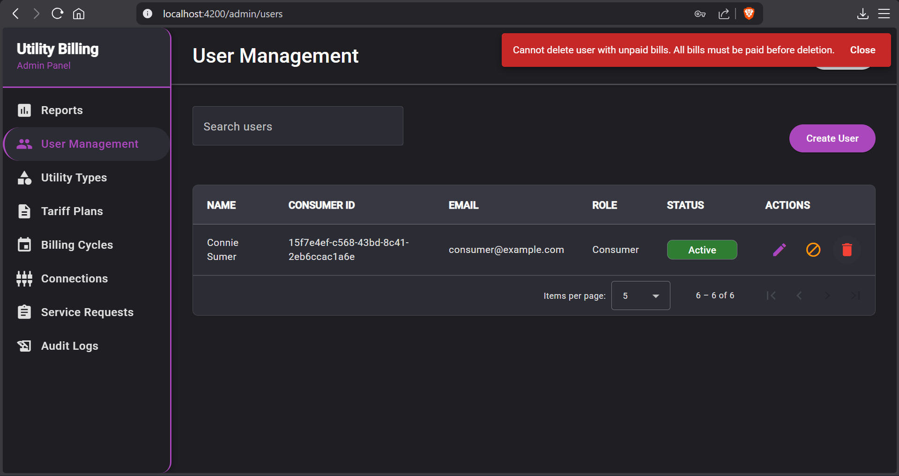

**12. Admin – Error message when admin tries to disable utility with active connections**

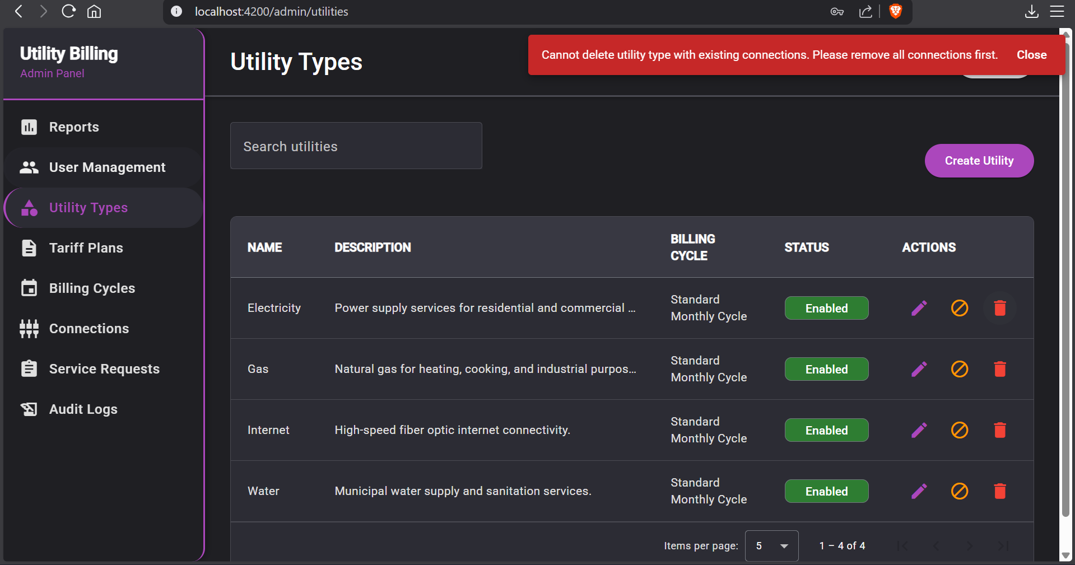

**13. Admin – Error message when admin tries to edit tariff before all meter readings have been recorded**

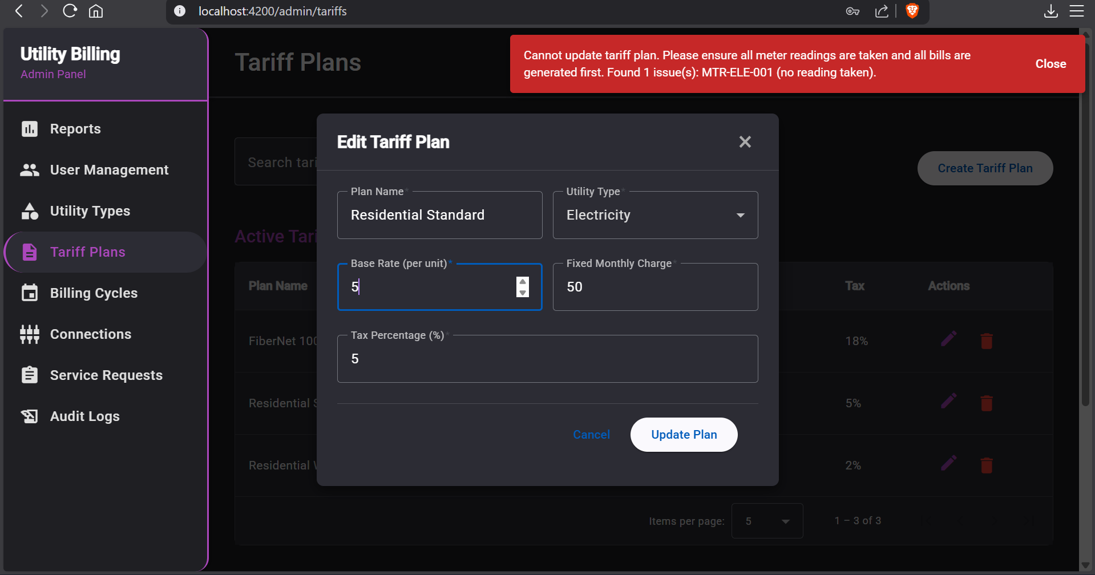

**14. Admin – Error message when admin tries to delete tariff plan with active connections**

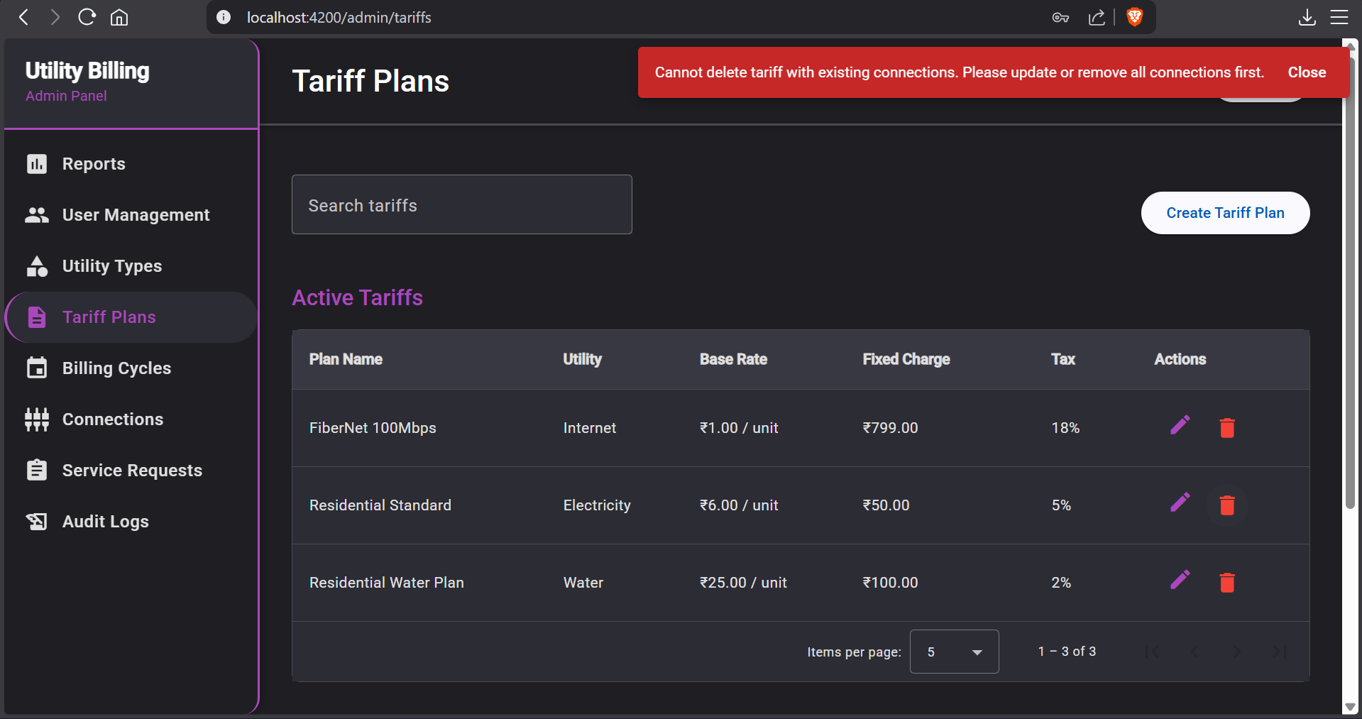

**15. Admin – Error message when admin tries to deactivate billing cycle with active utility types**

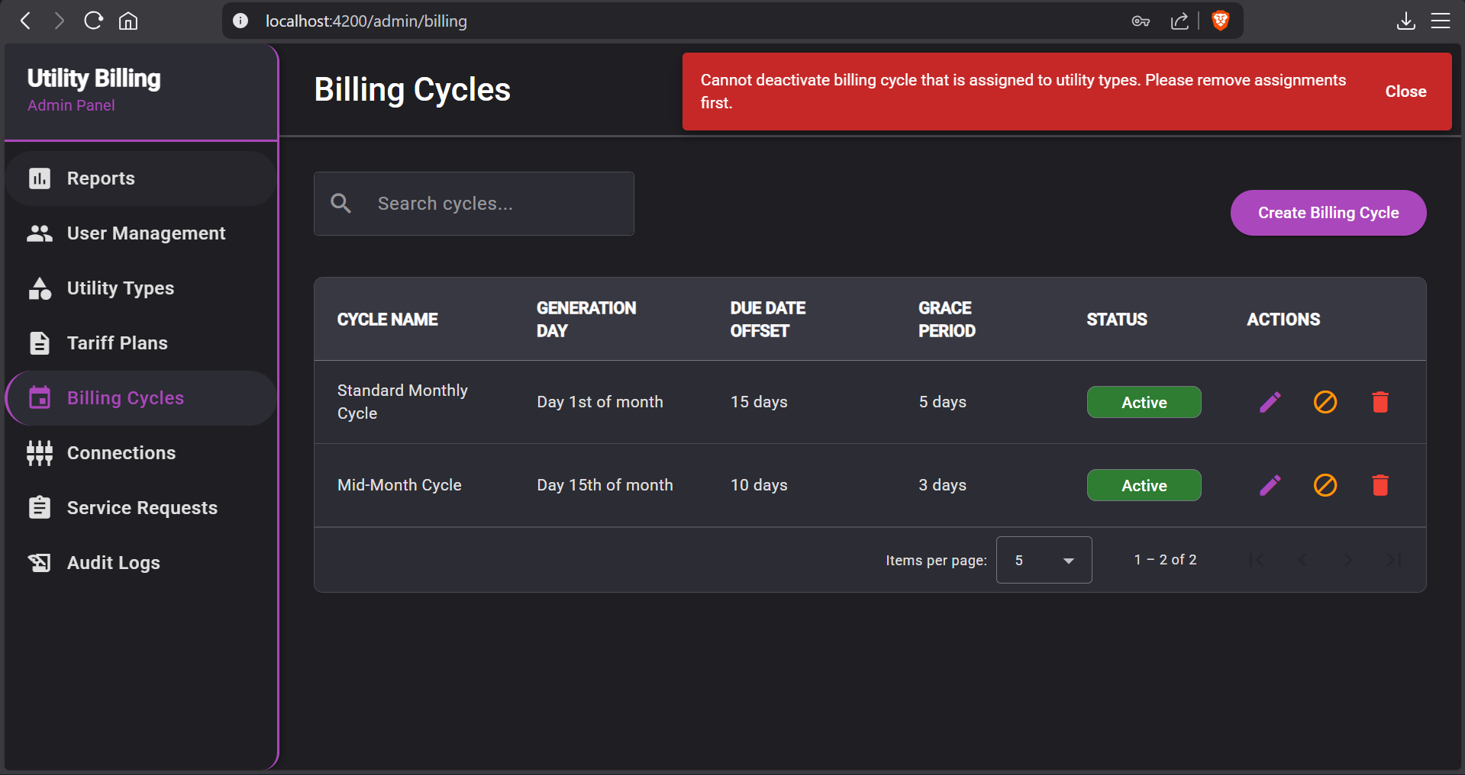

**16. Admin – Error message when admin tries to delete Consumer with unpaid bills**

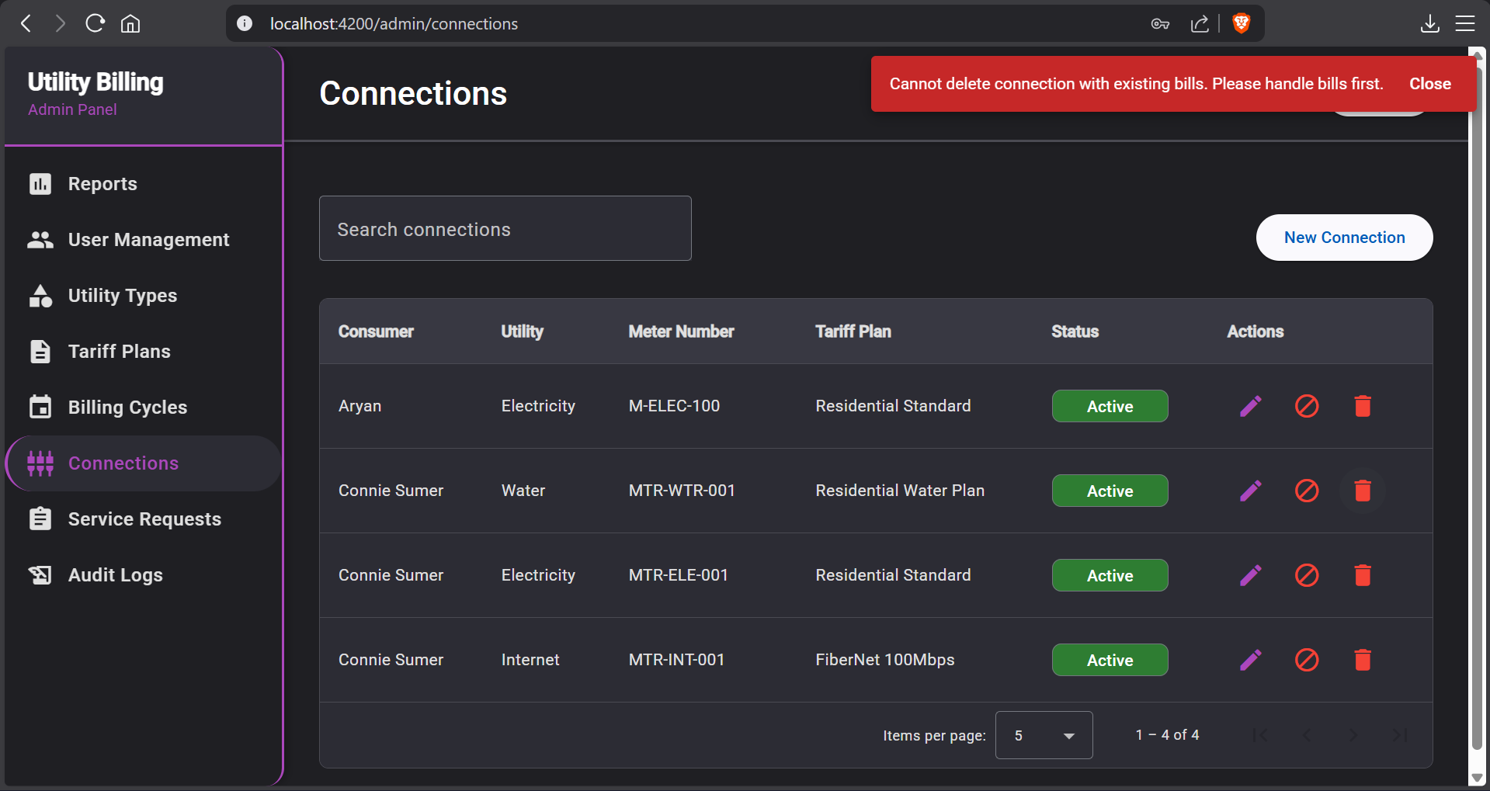

**17. Admin – Create user form**

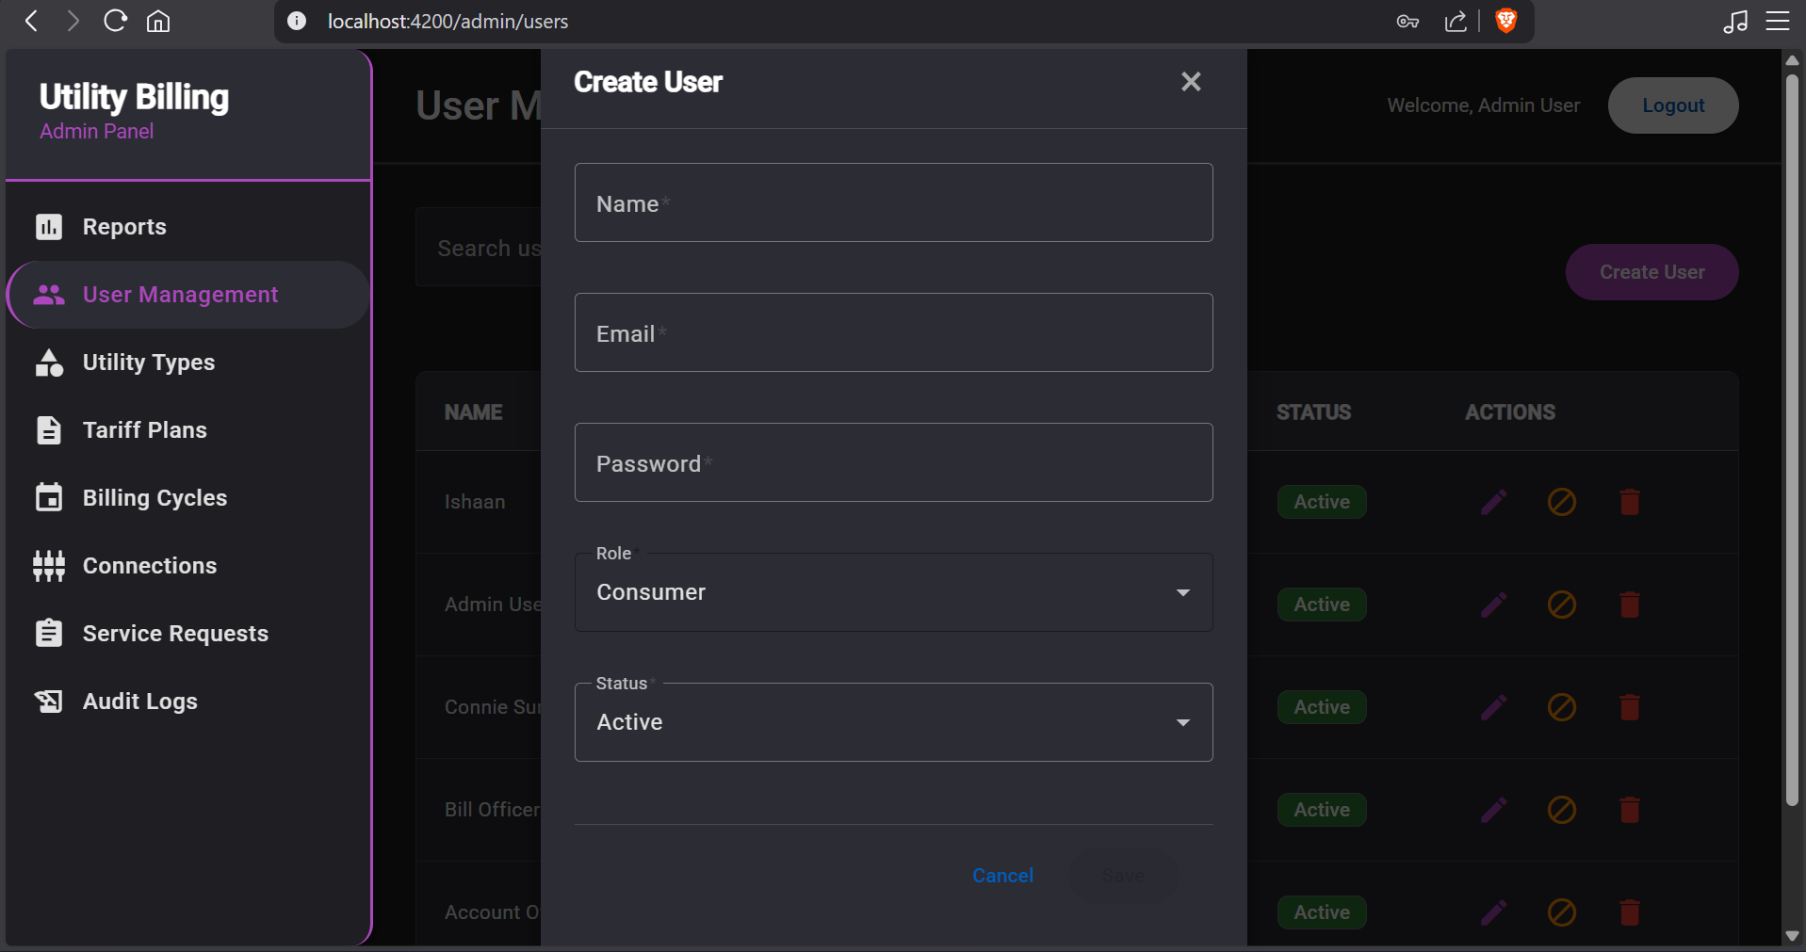

**18. Admin - Create utility form**

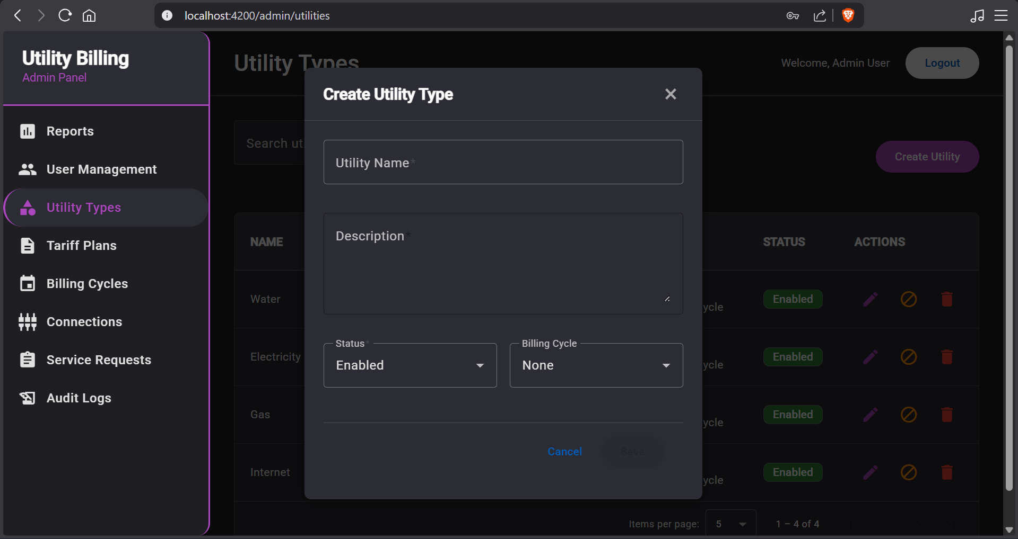

**19. Admin – edit utility form**

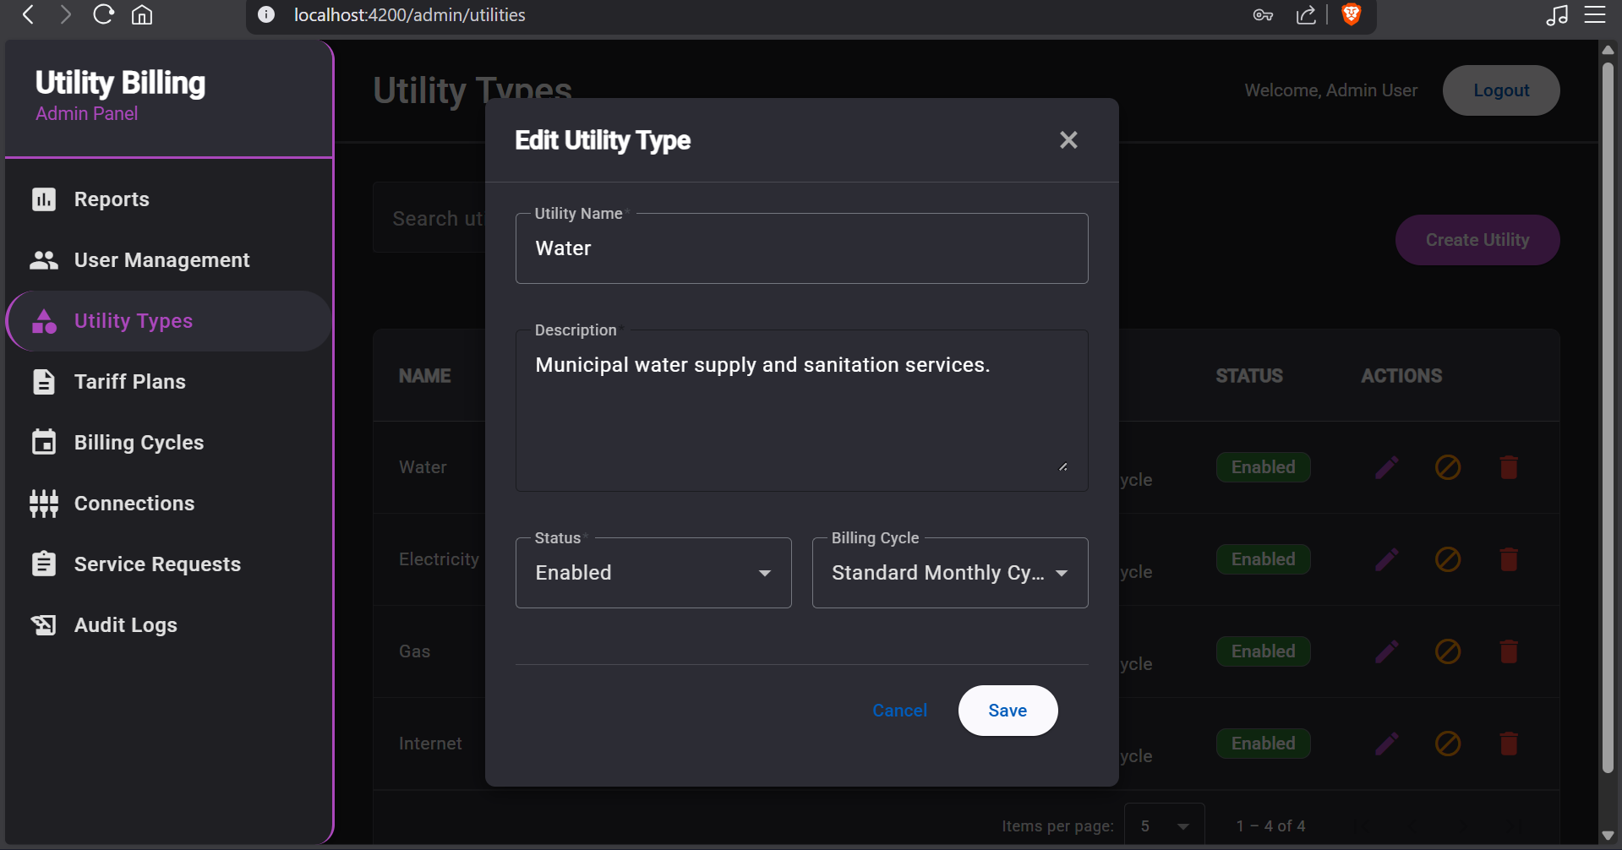

**20. Admin – edit tariff form**

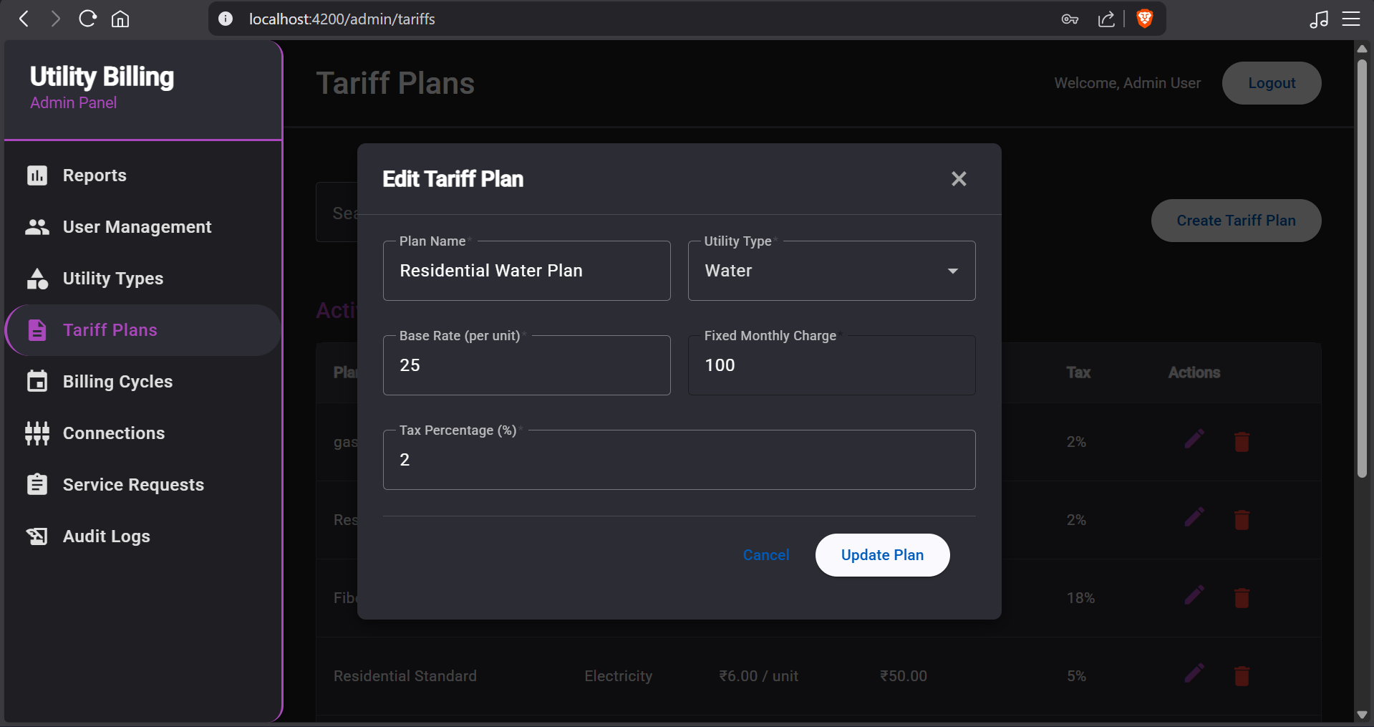

**21. Admin – Create billing cycle form**

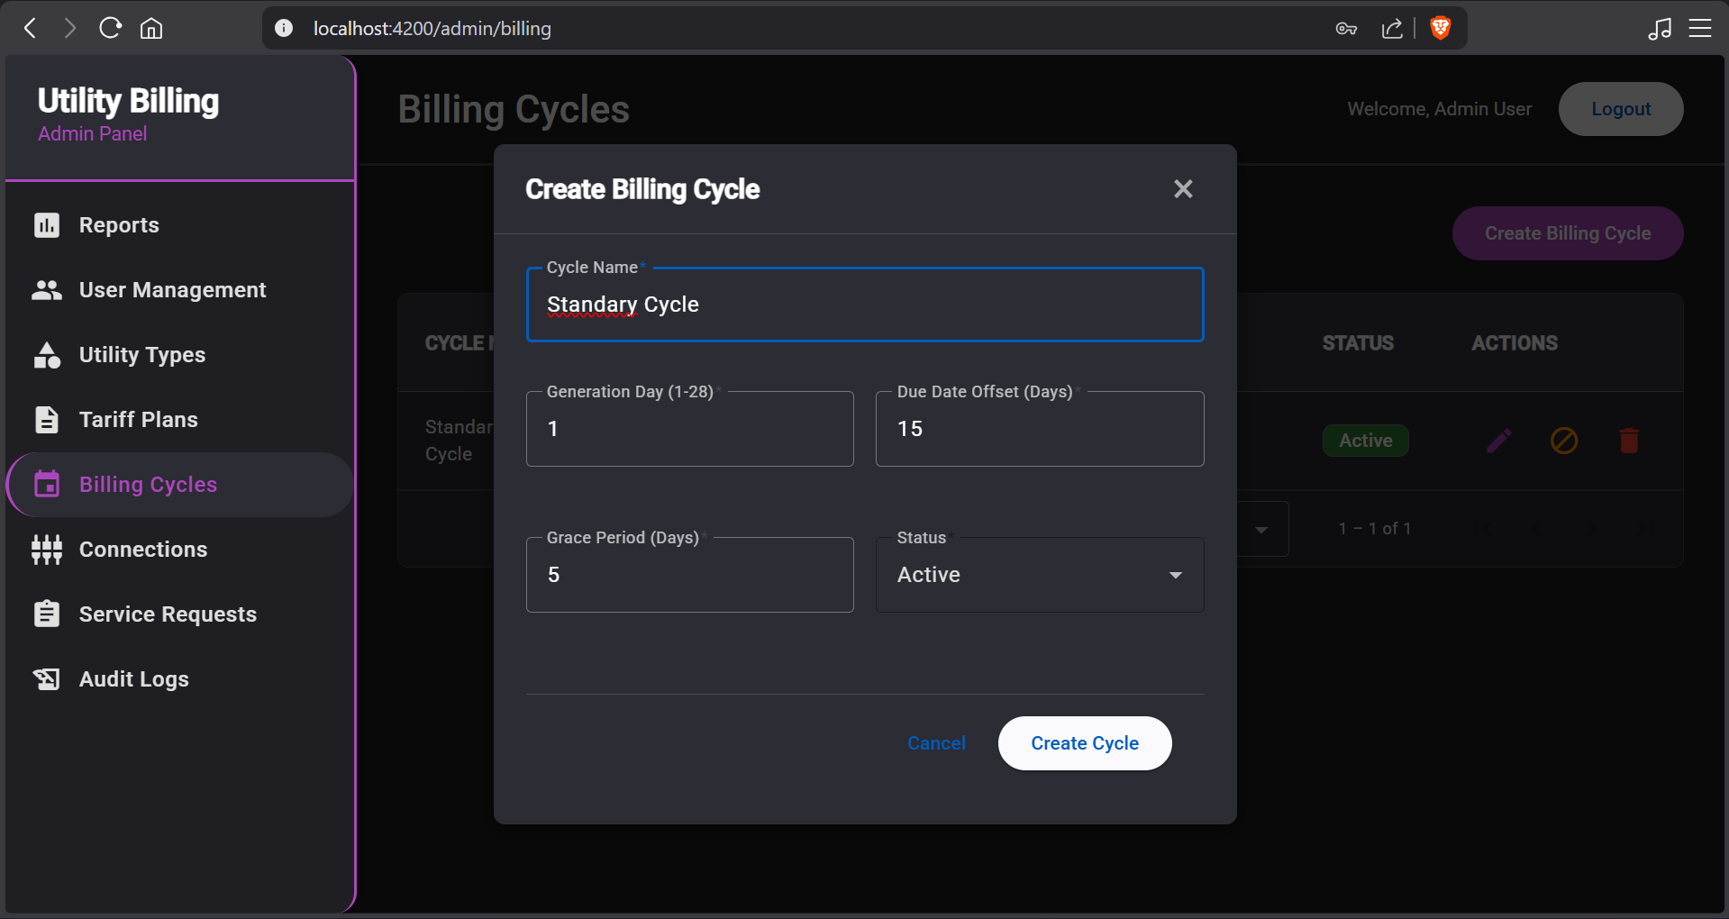

**22. Admin – Create new connection form**

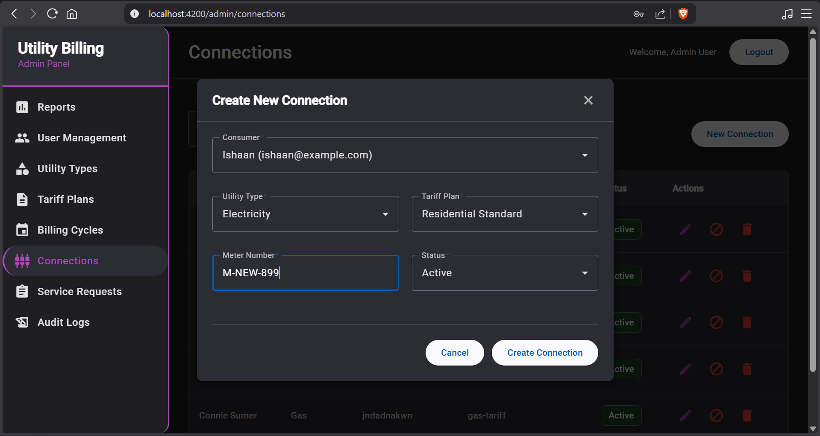

**BILLING OFFICER (BO)**

**23. BO – Meter Reading Entry page**

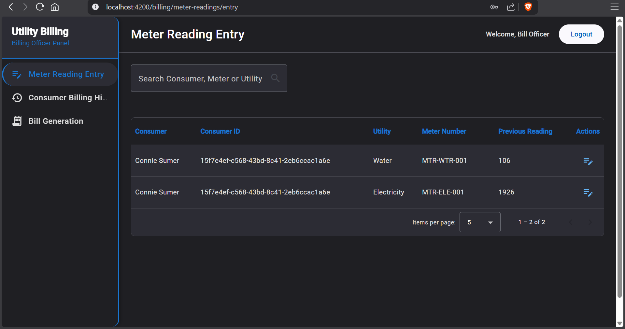

**24. BO - Consumer Billing History page**

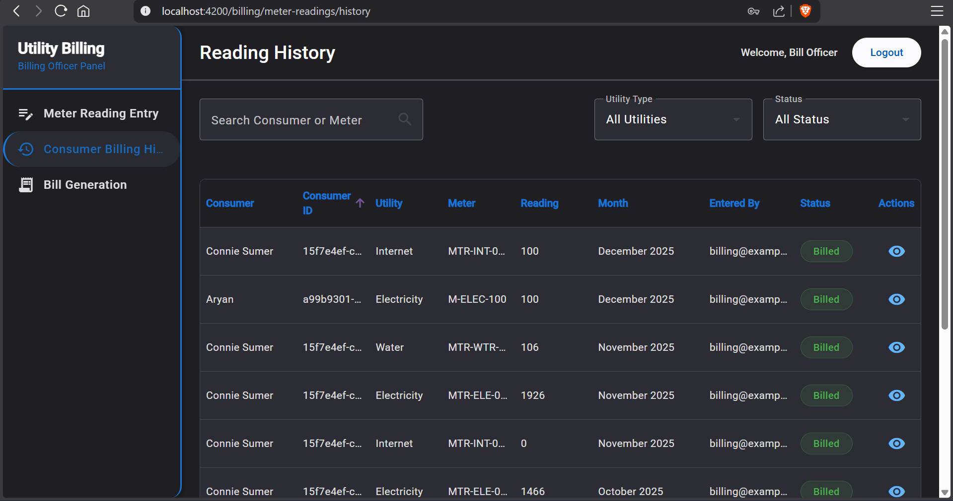

**25. BO – Bill Generation page**

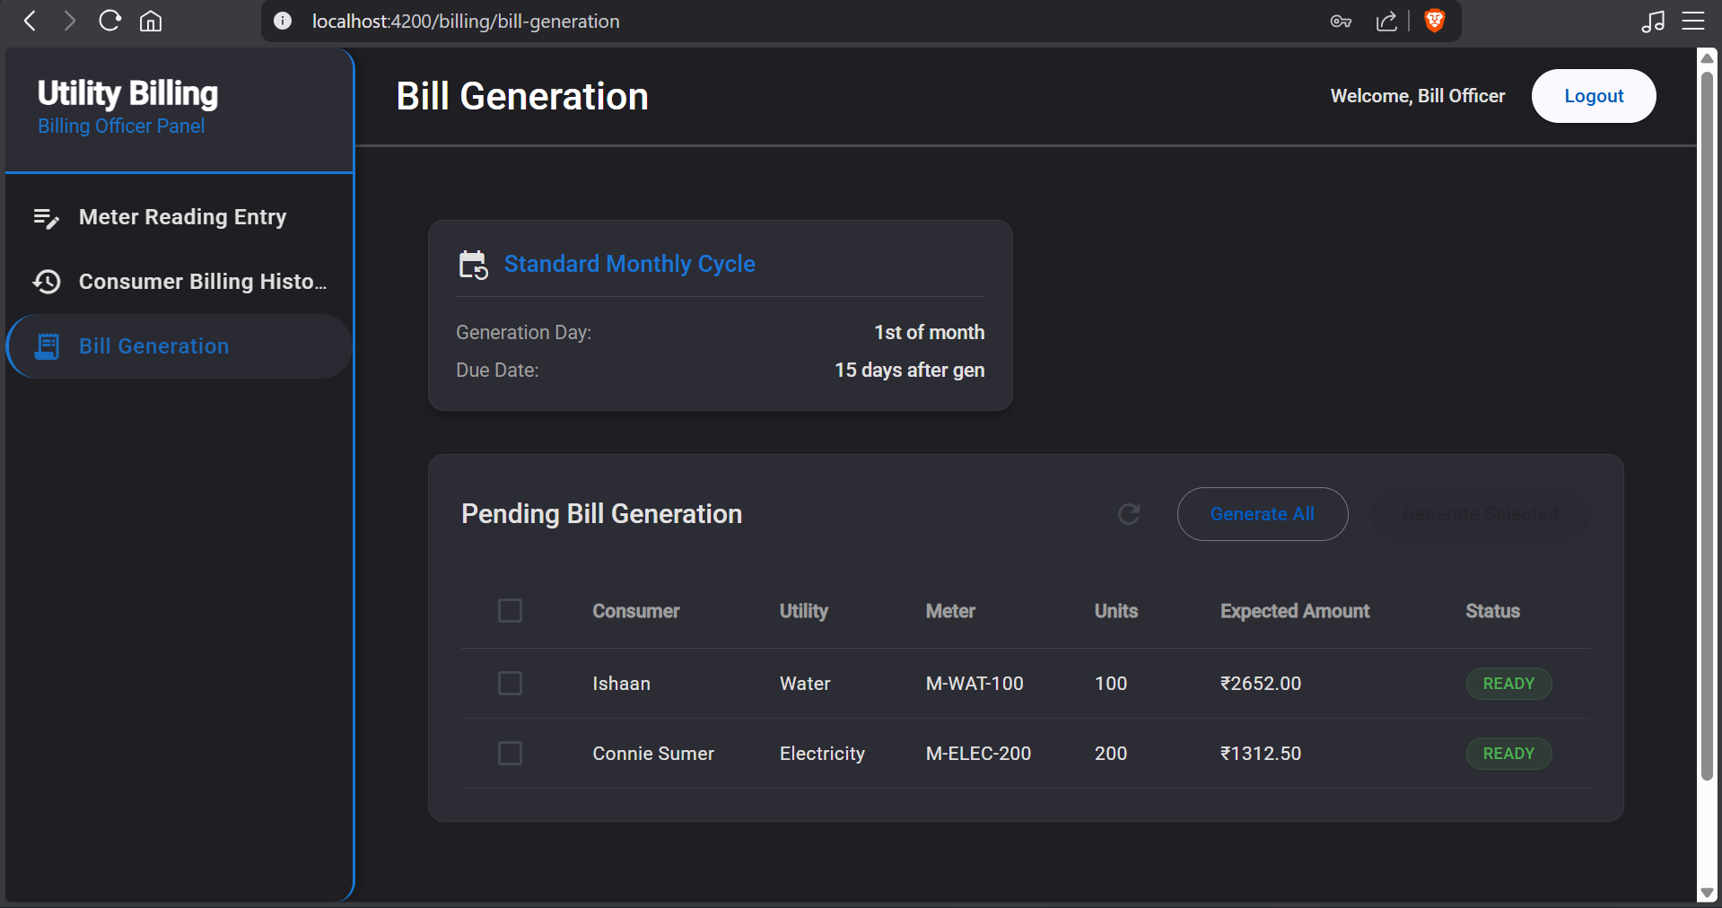

**26. BO – Meter reading entry form**

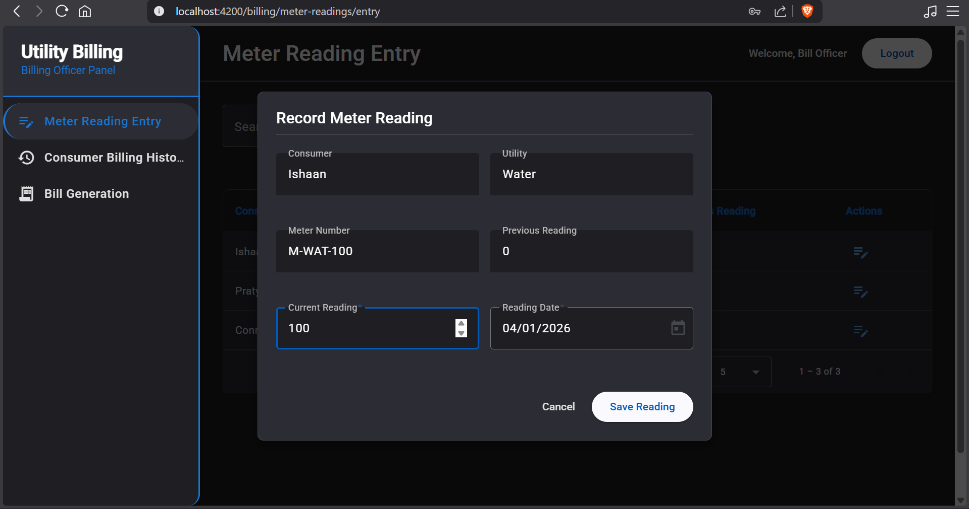

**27. BO – Meter reading details form**

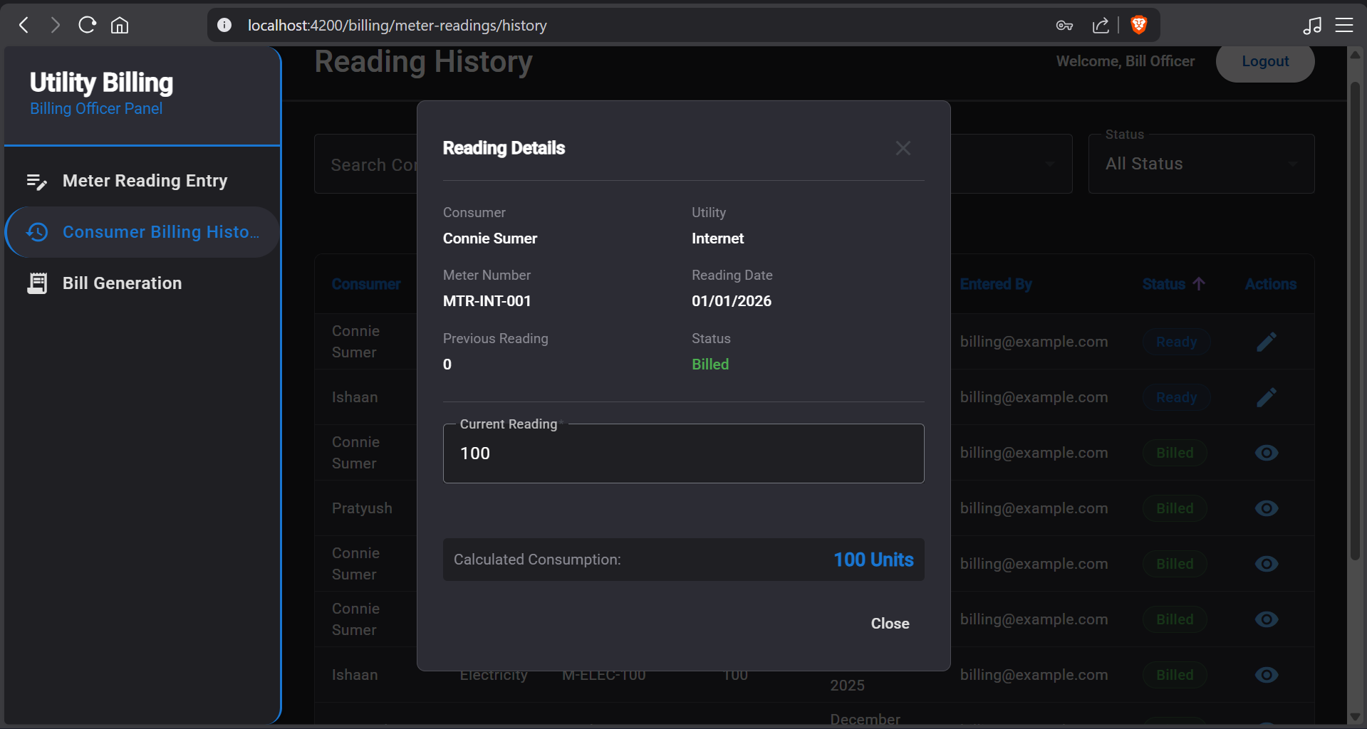

**28. BO – Confirm Bill generation popup**

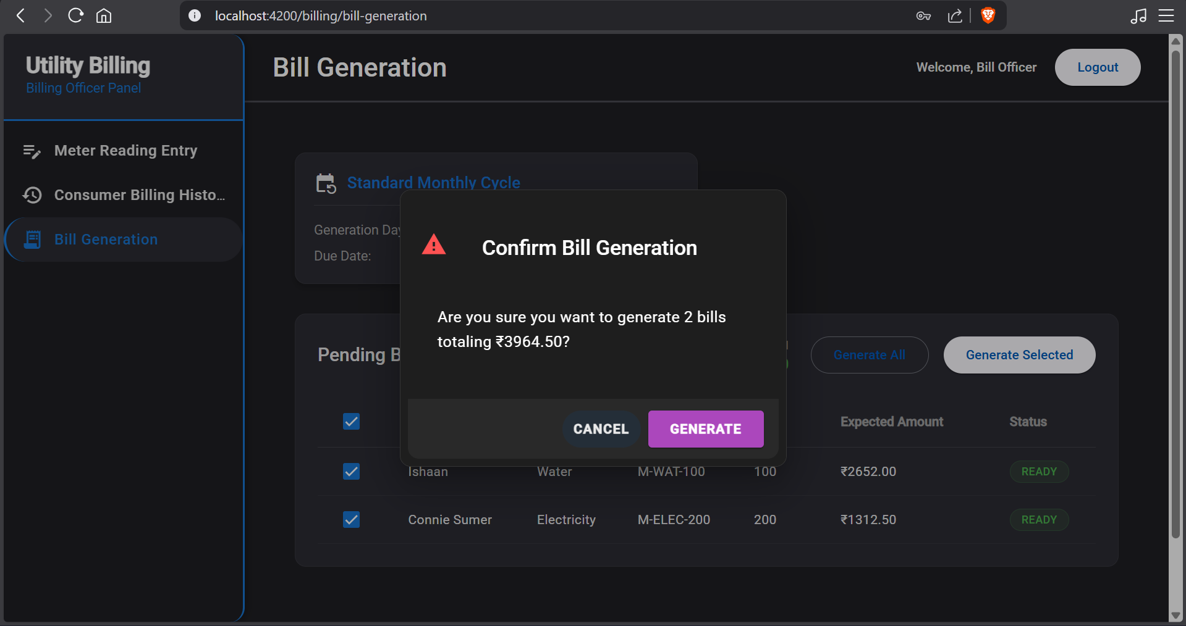

**Account Officer (AO)**

**29. AO – Dashboard**

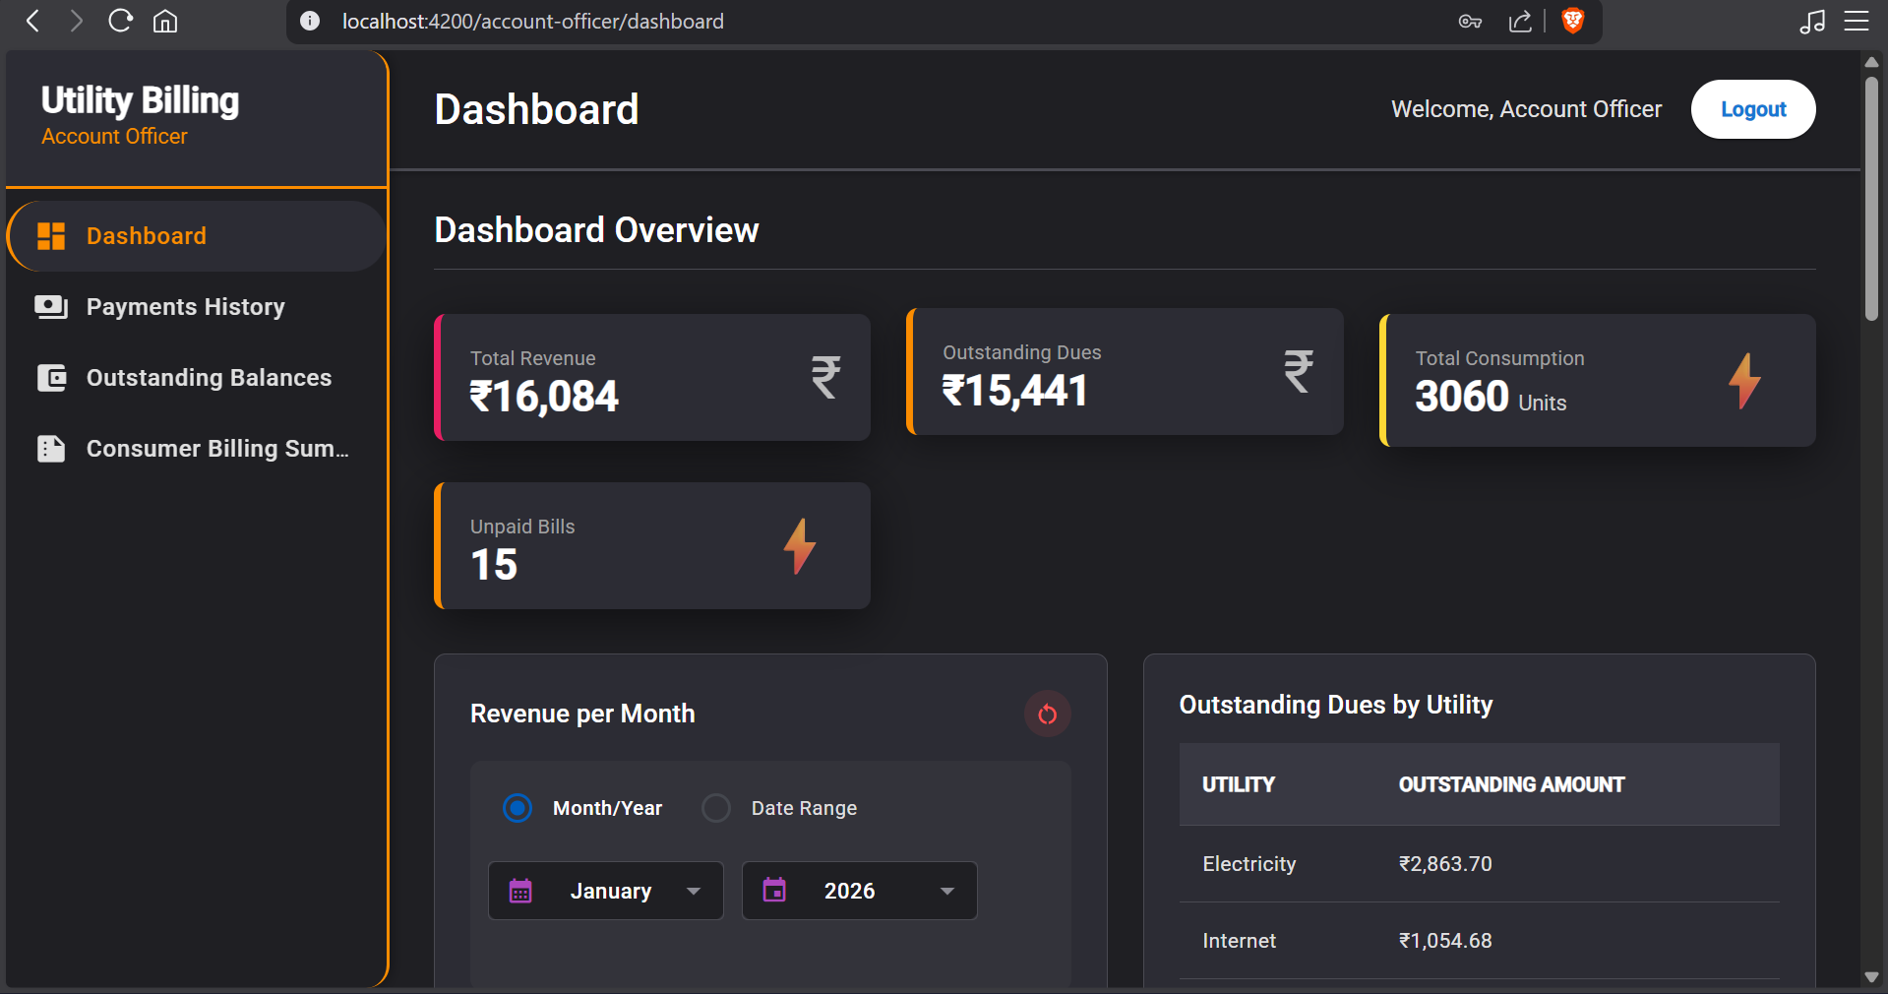

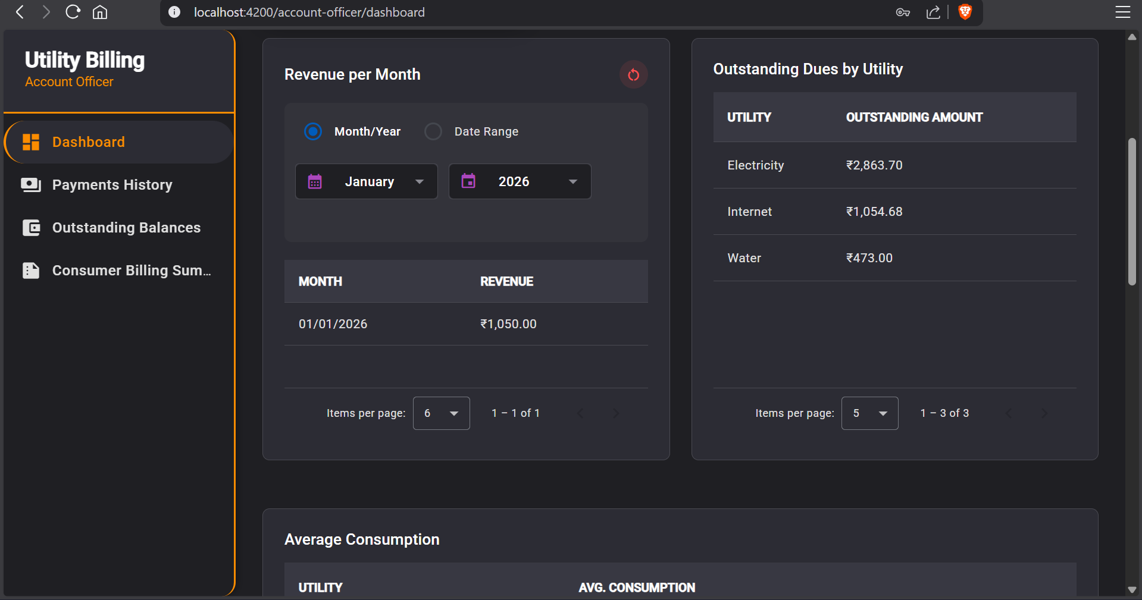

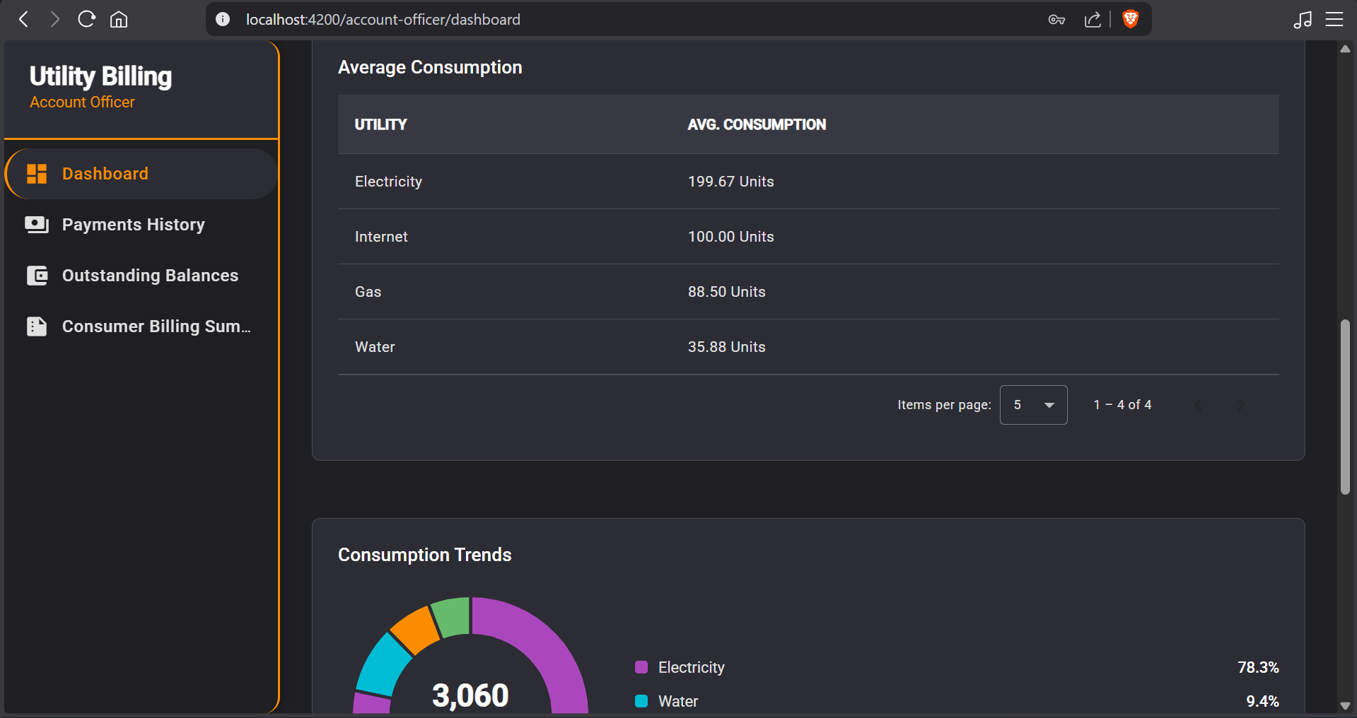

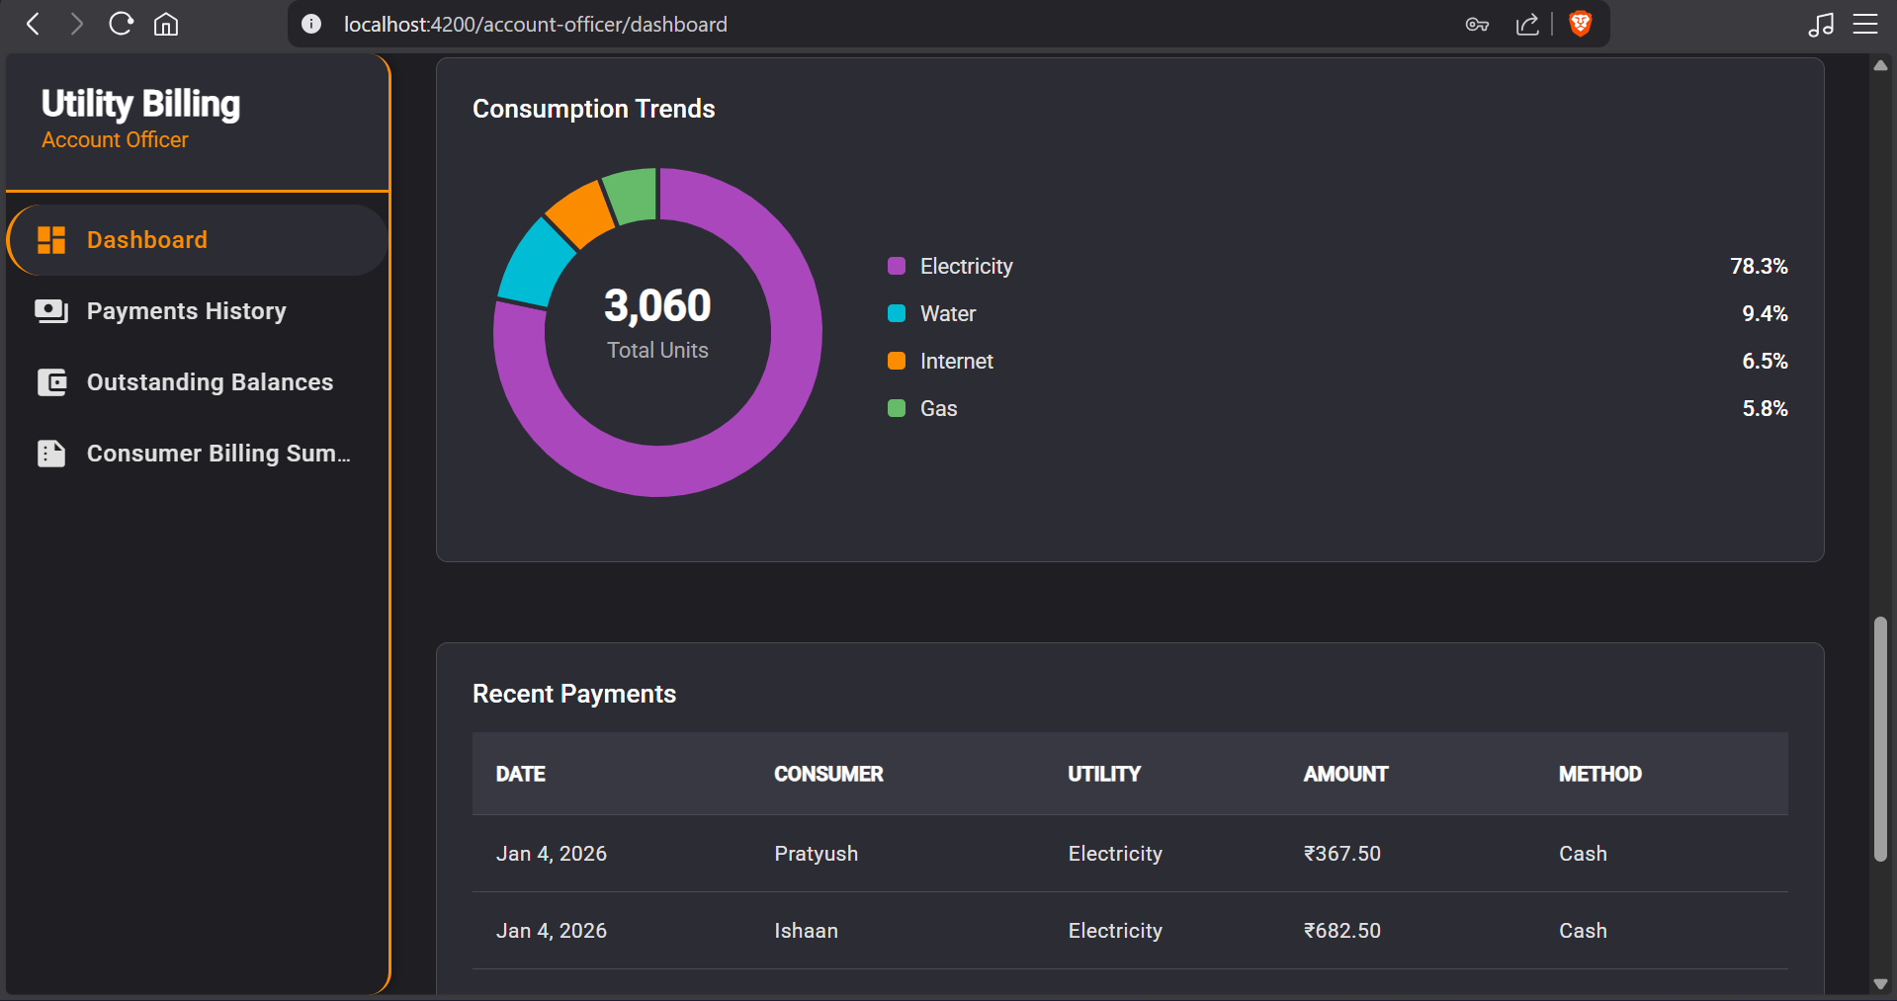

**30. AO – Payments history page**

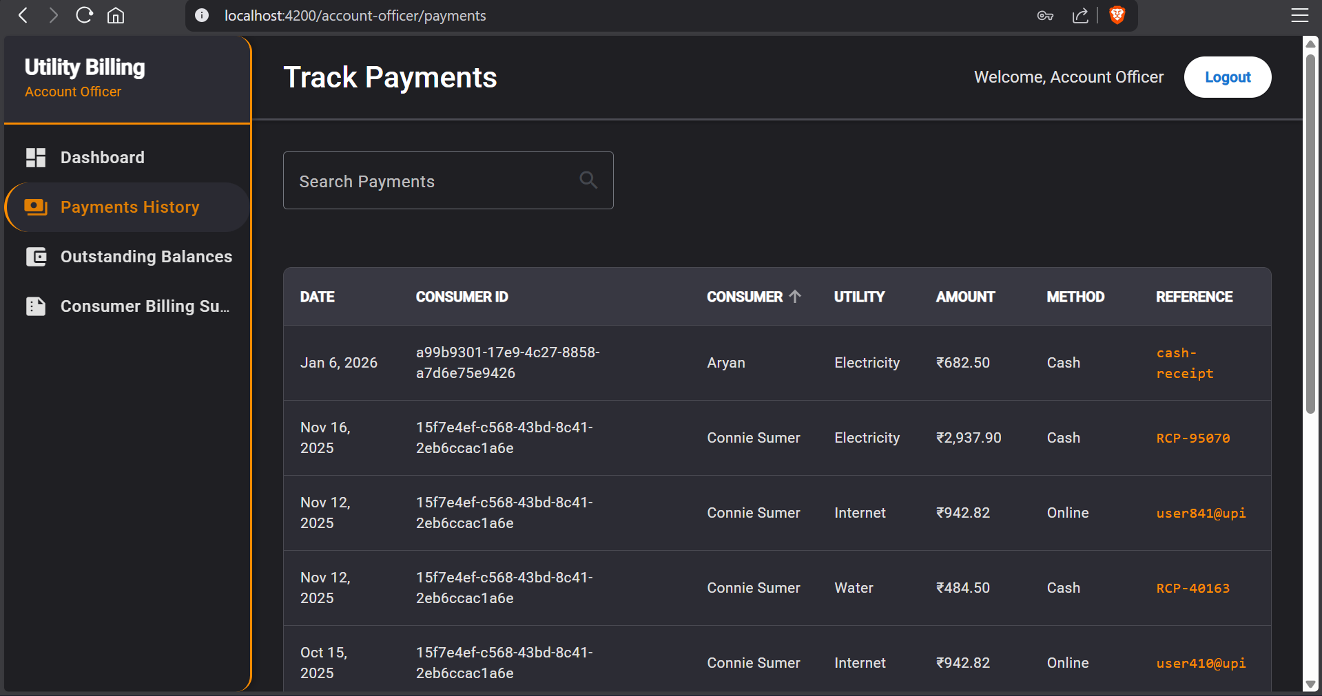

**31. AO – Outstanding Balances page**

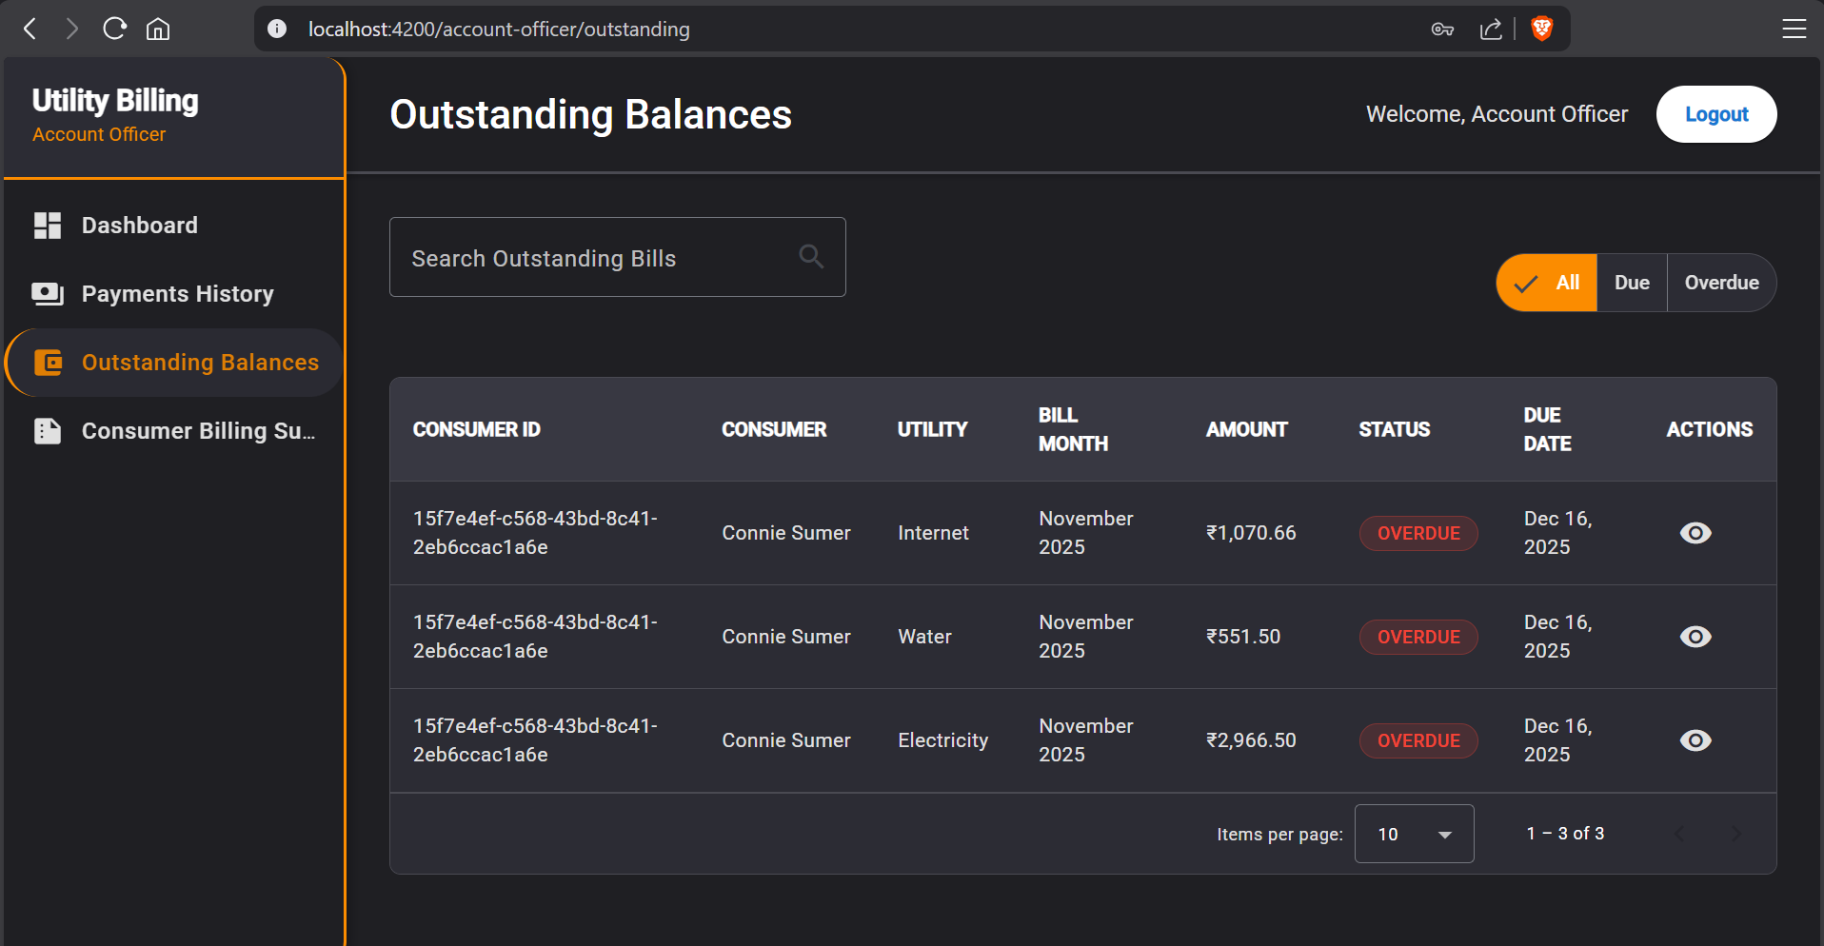

**32. AO – Consumer Billing Summary page**

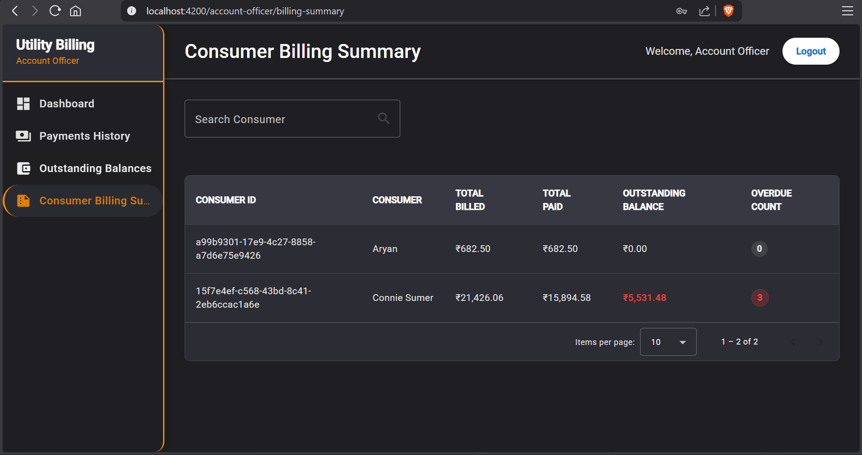

**CONSUMER**

**33. Consumer – Dashboard**

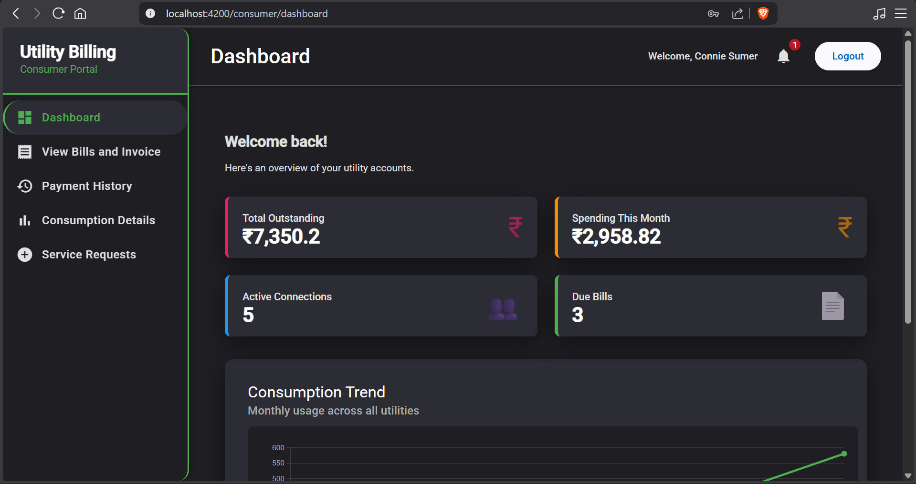

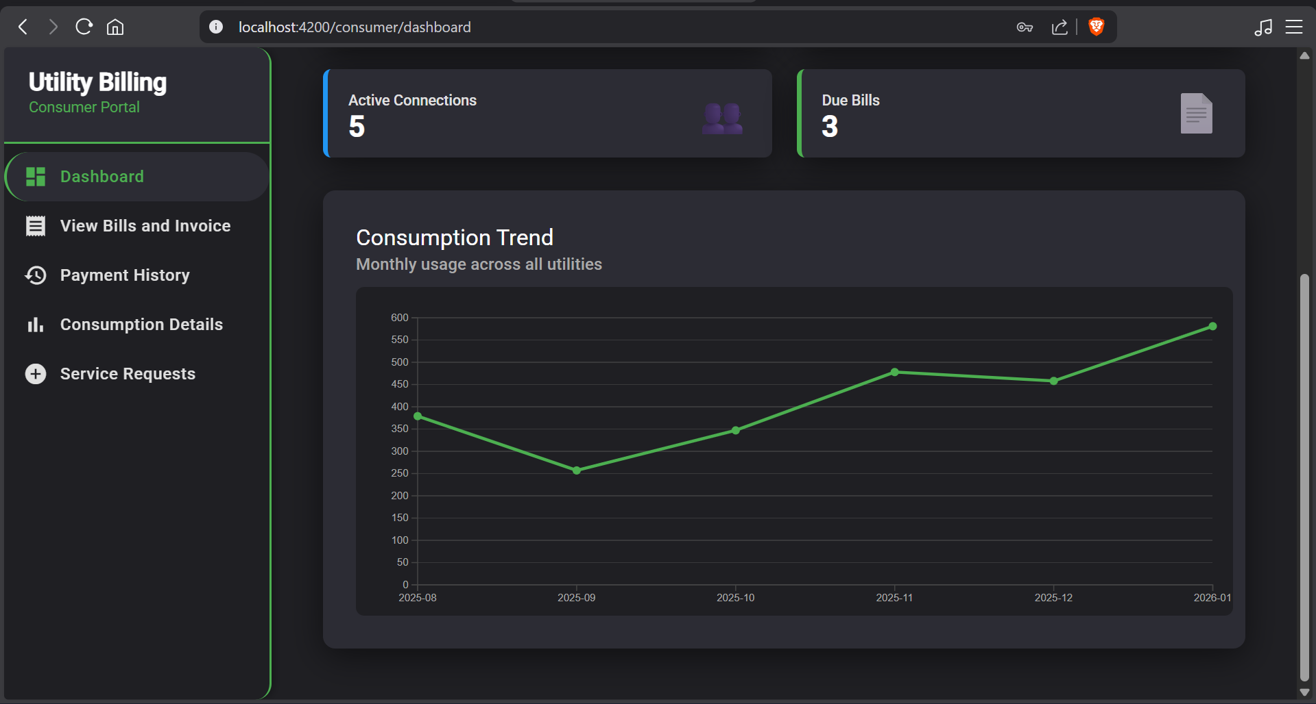

**34. Consumer – Notifications view**

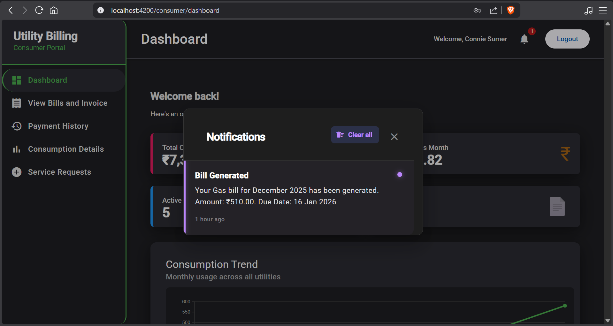

**35. Consumer – View Bills and Invoice page**

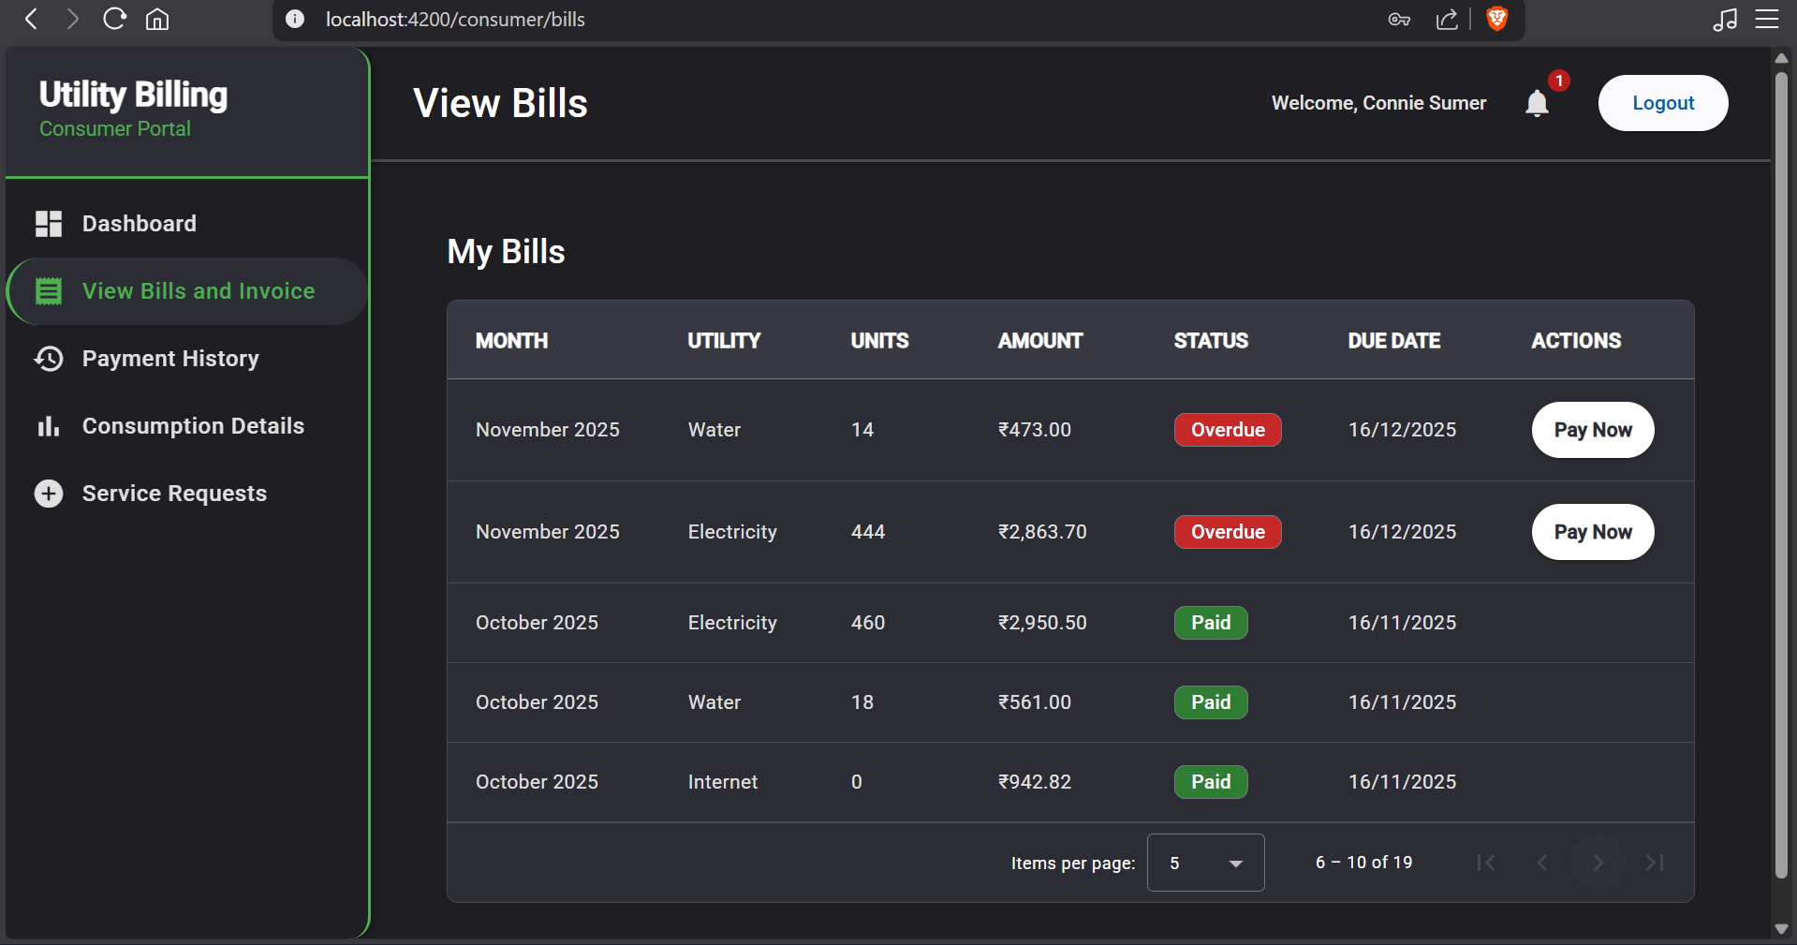

**36. Consumer – Payment History page**

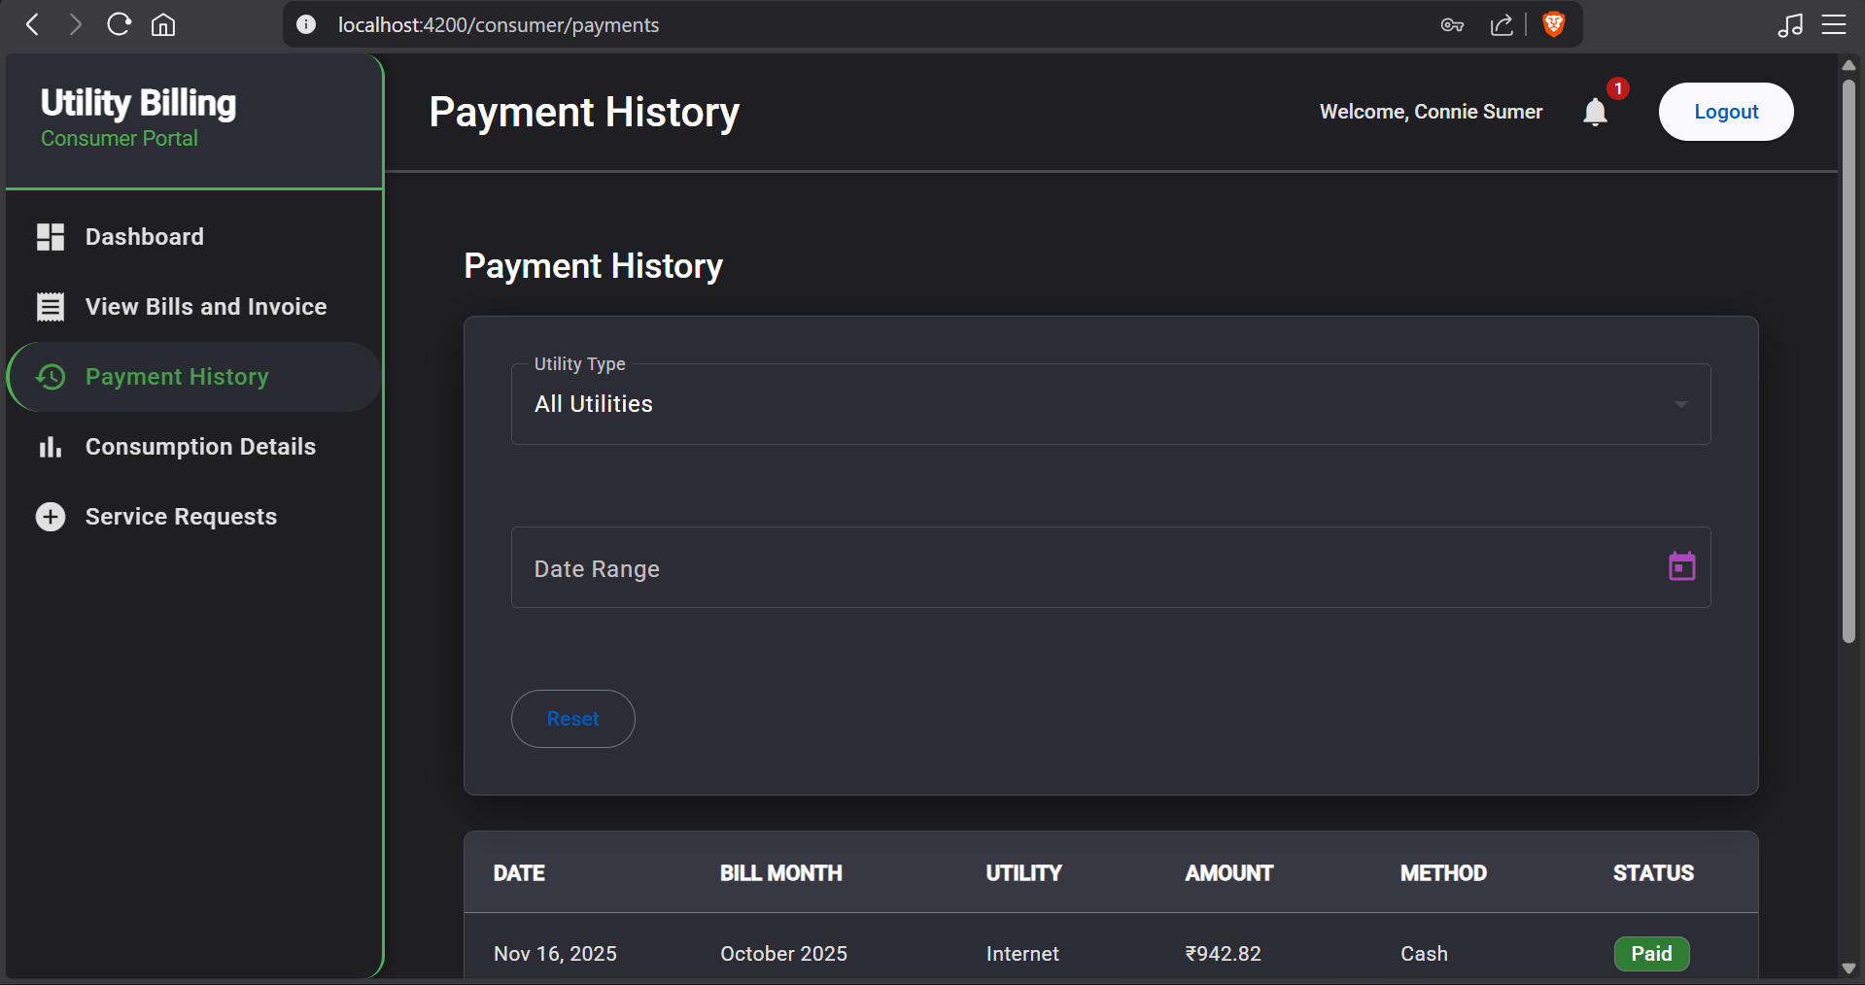

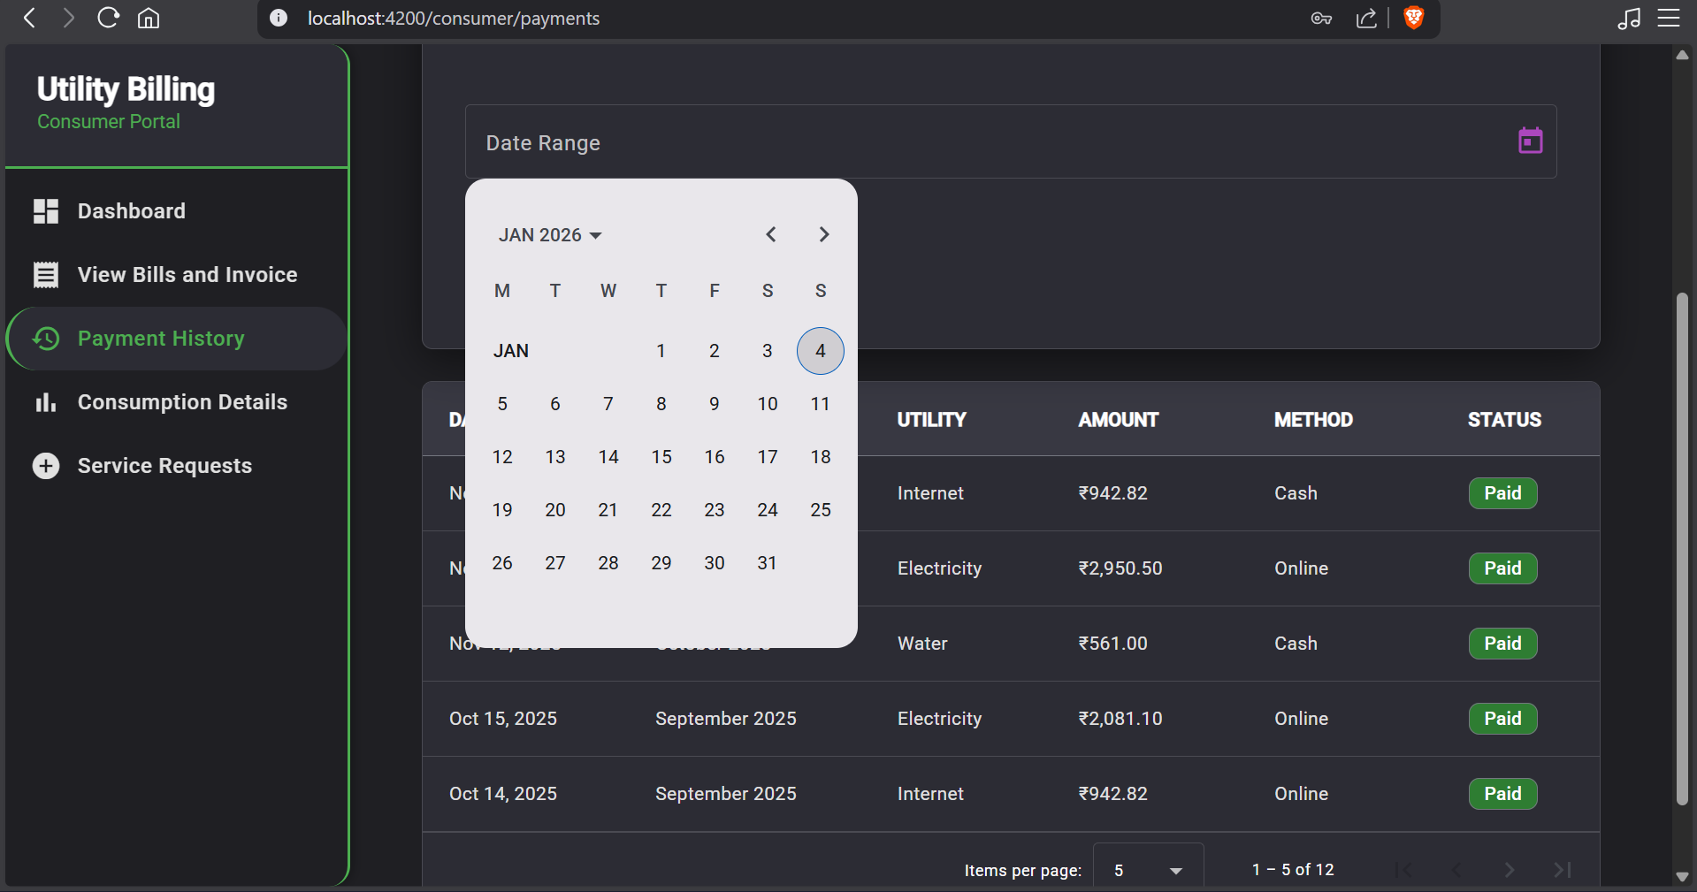

**37. Consumer – Consumption Details page**

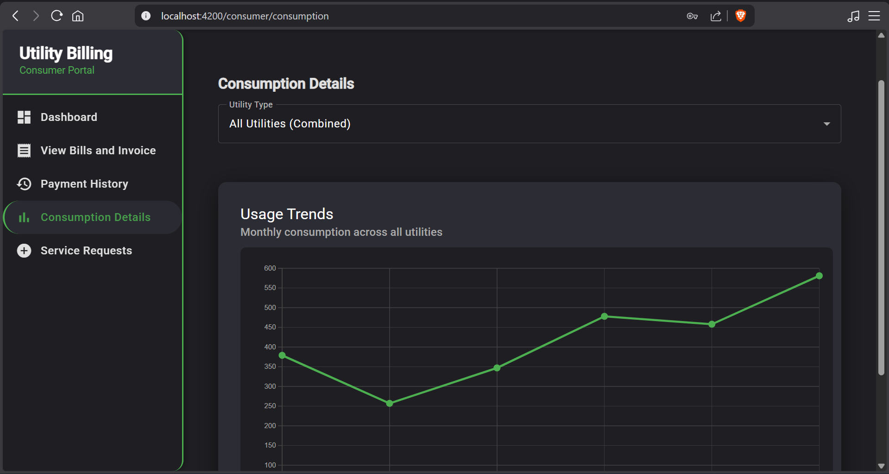

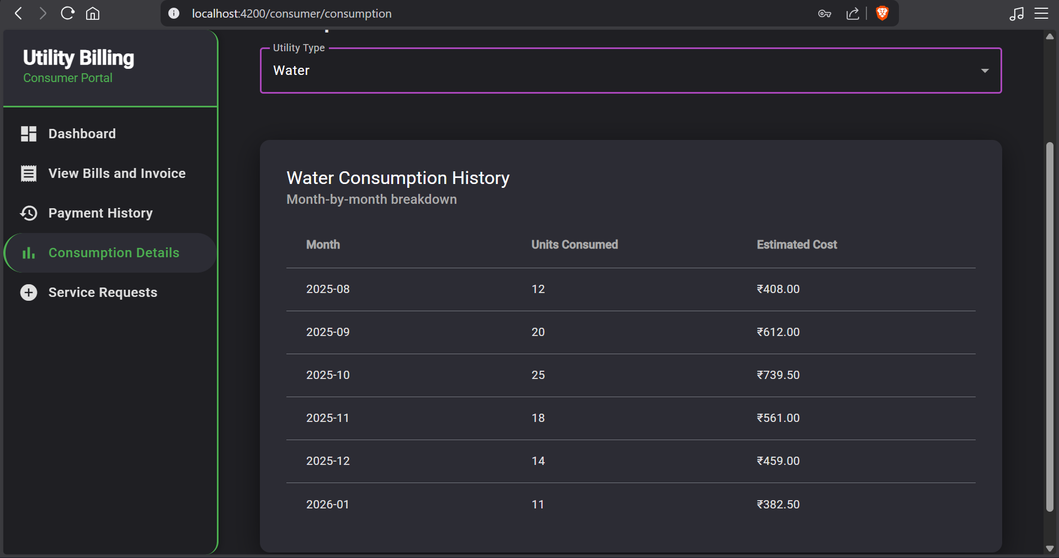

**38. Consumer – Service Request page**

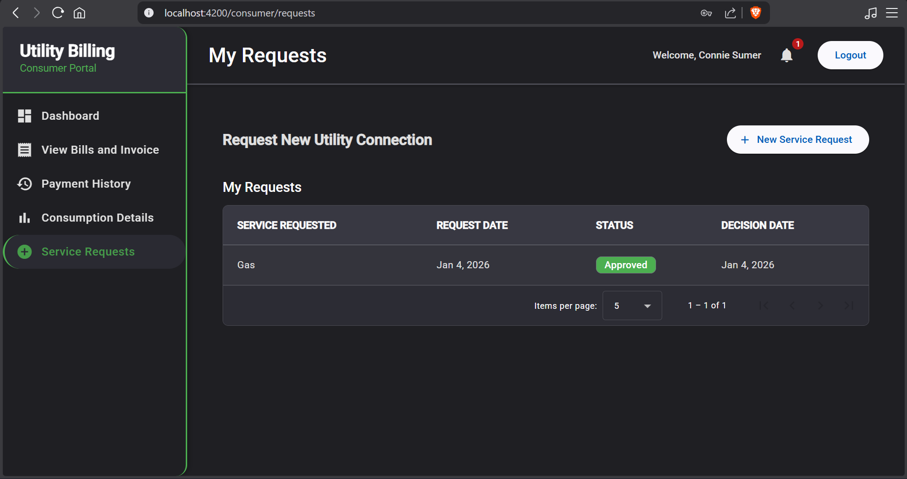

**39. Consumer –Payment form (Online or Cash)**

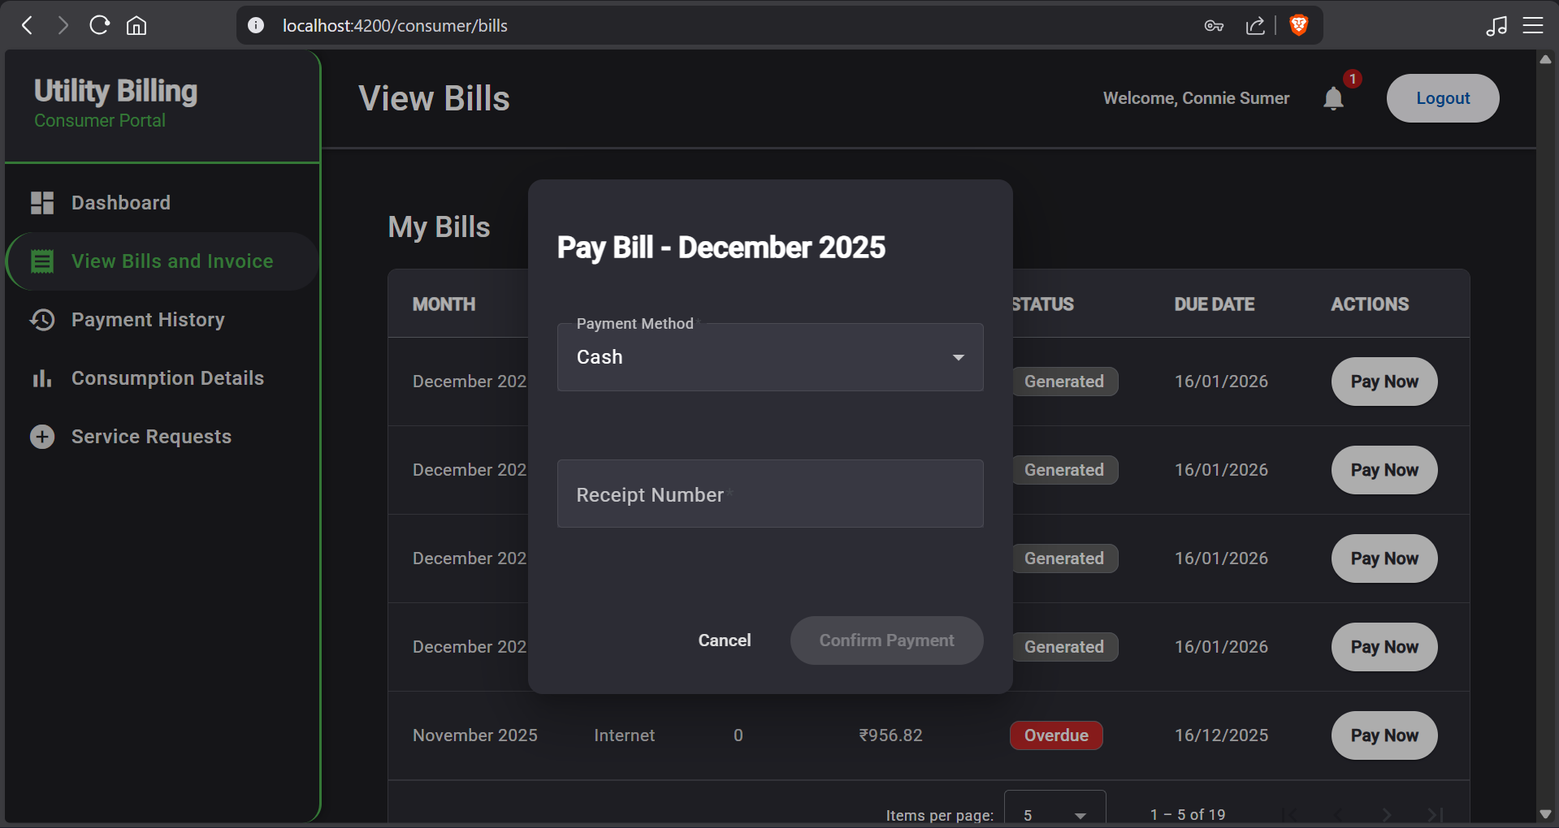

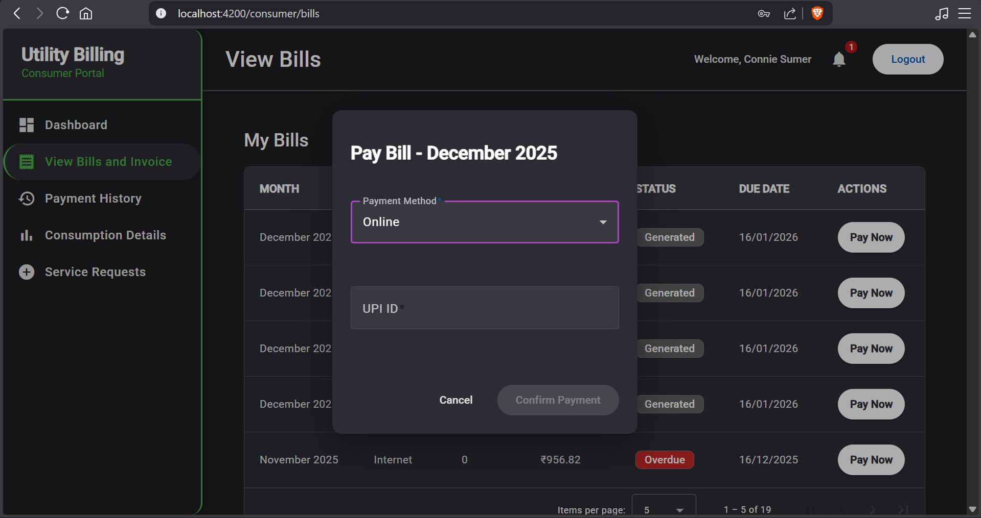

**POSTMAN SCREENSHOTS**

**Consumer**

1.Customer tries to access ALL outstanding bills for which he isn’t authorized

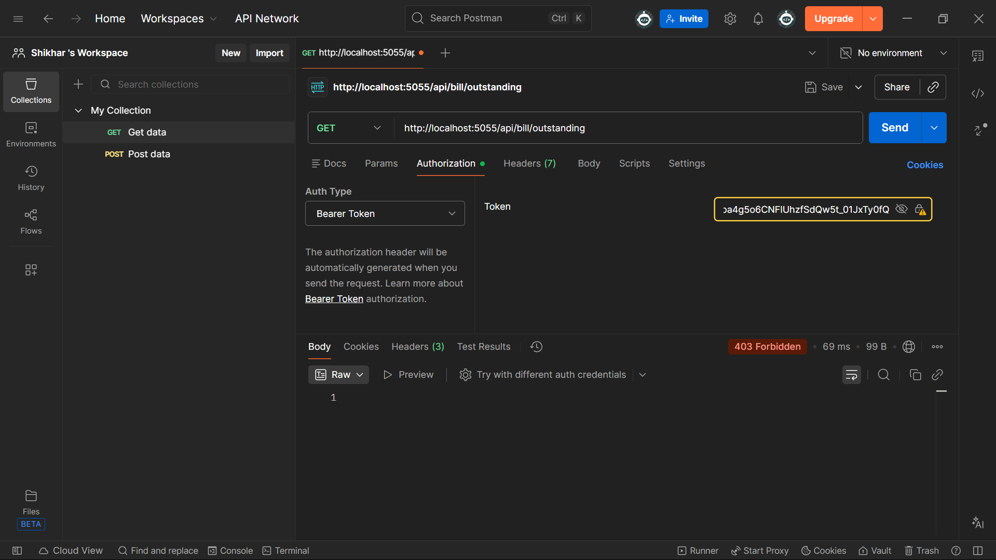

2. Consumer tries to access ALL meter readings for which he isn’t authorized

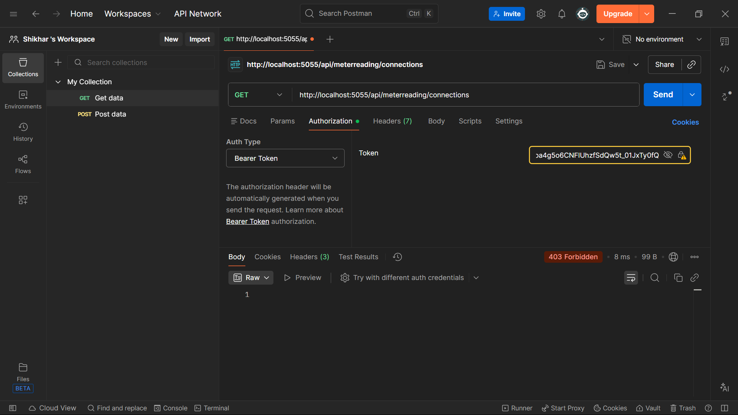

3. Consumer tries to update Billing Cycle which is admin only

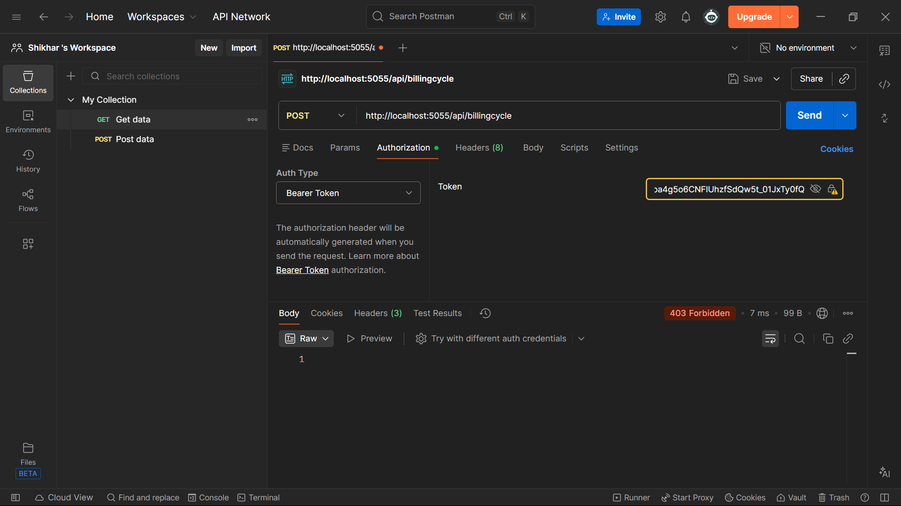

4. Consumer can access his own notifications

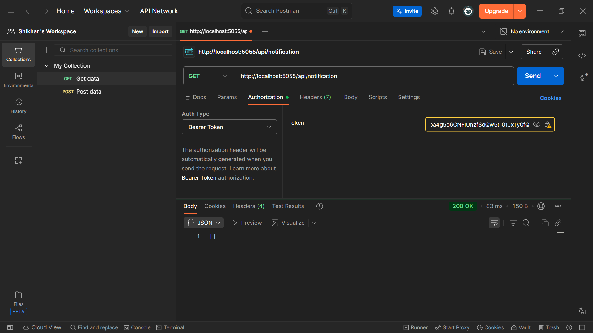

**Admin**

1. Admin cant access Consumers Notification

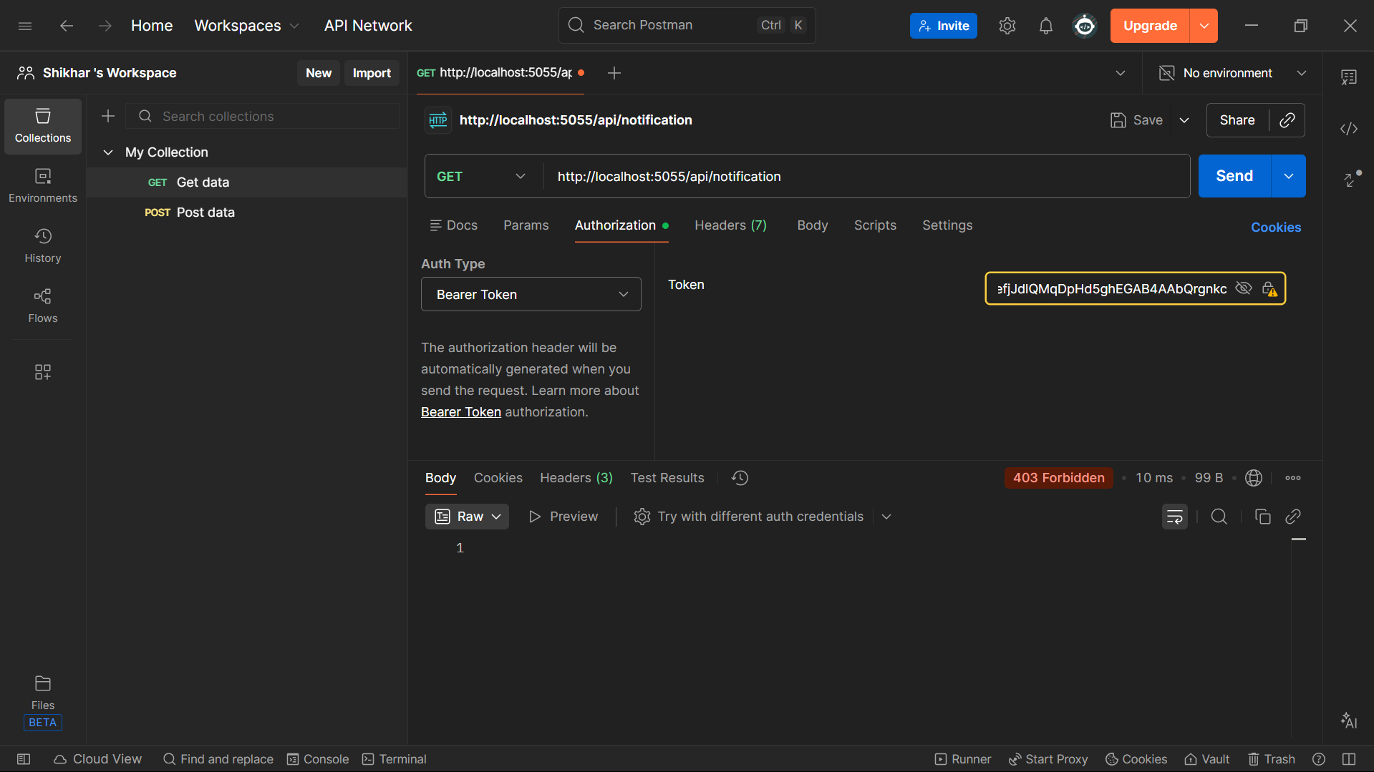

2. Admin cant access bills which is billing officer functionality

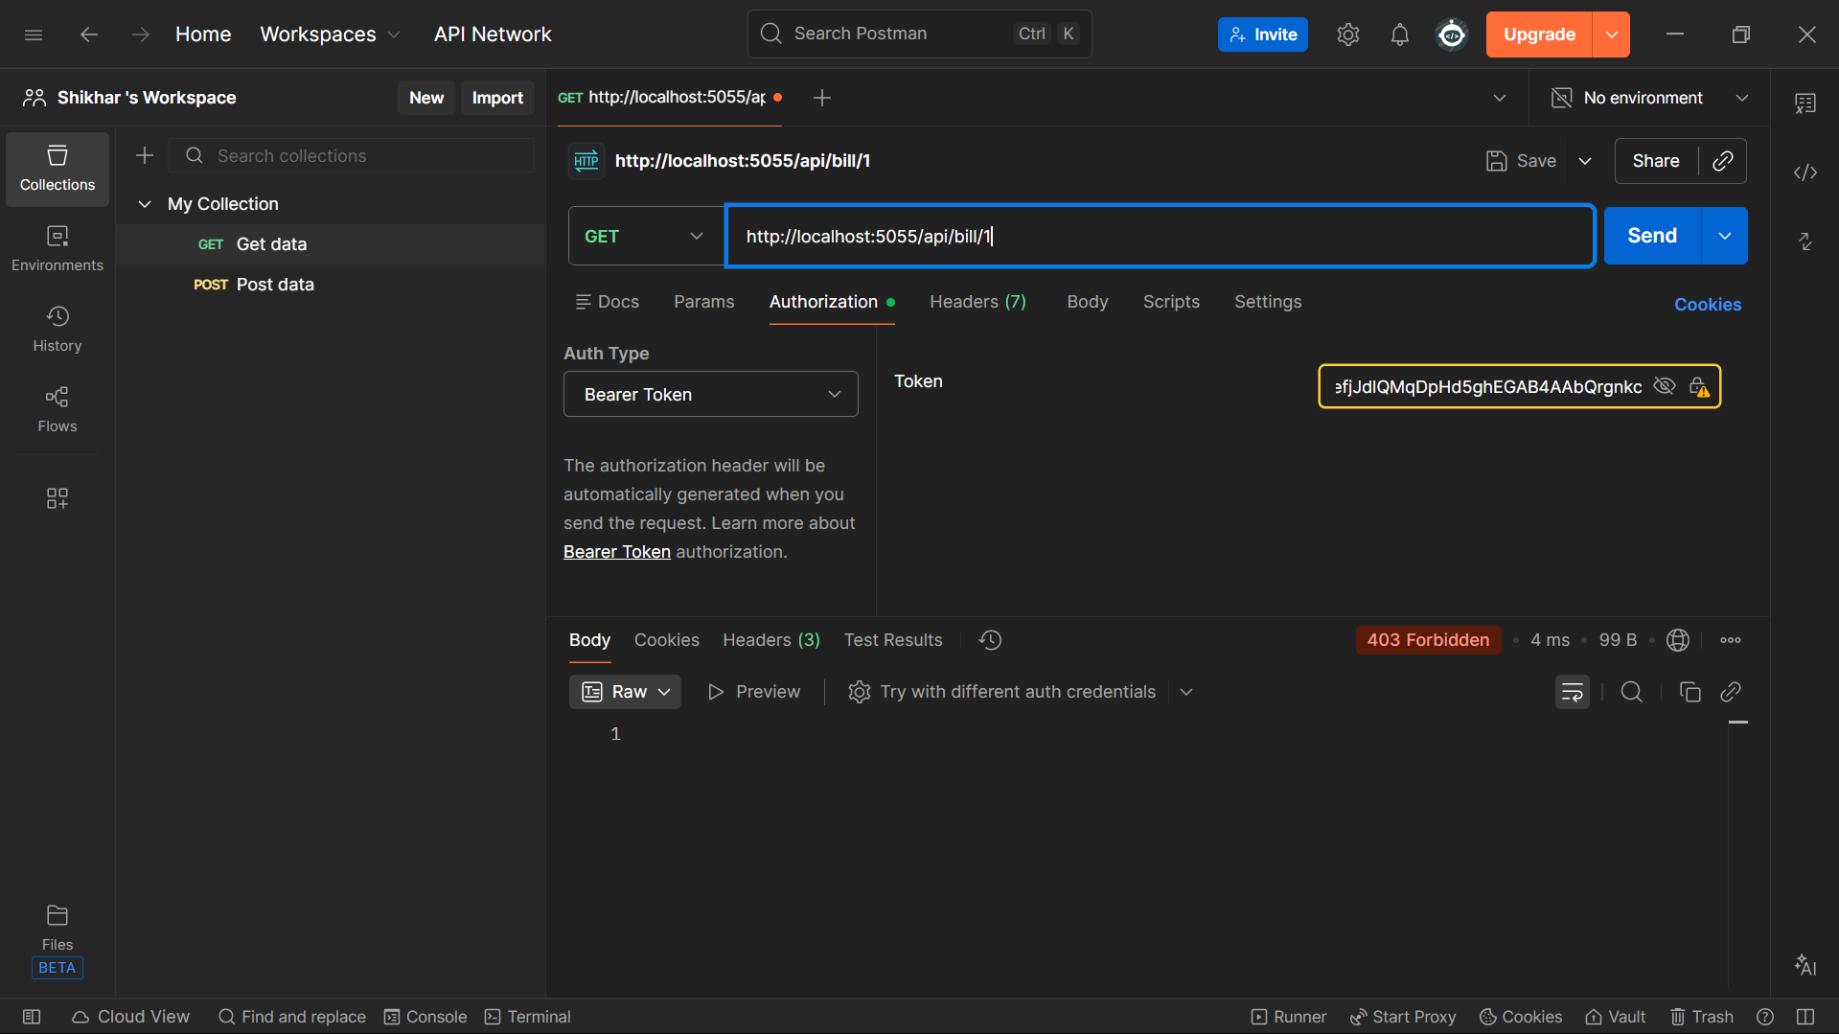

3. Admin cant access Payments because that is account officer/consumer function

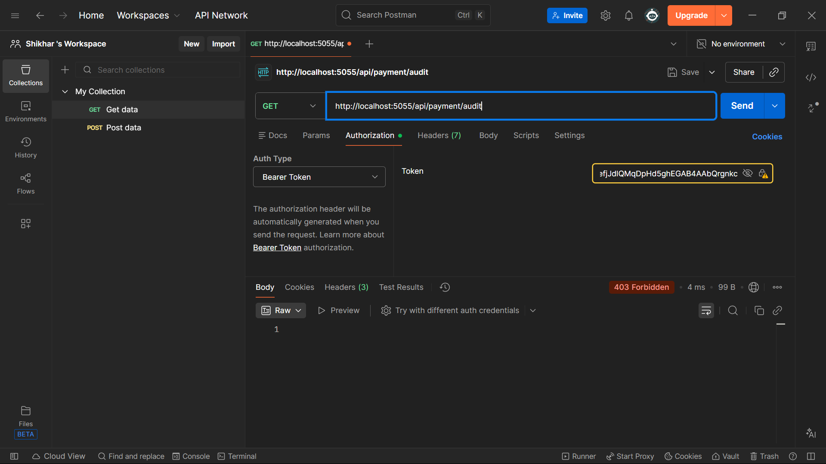

4. Admin can access all Connections

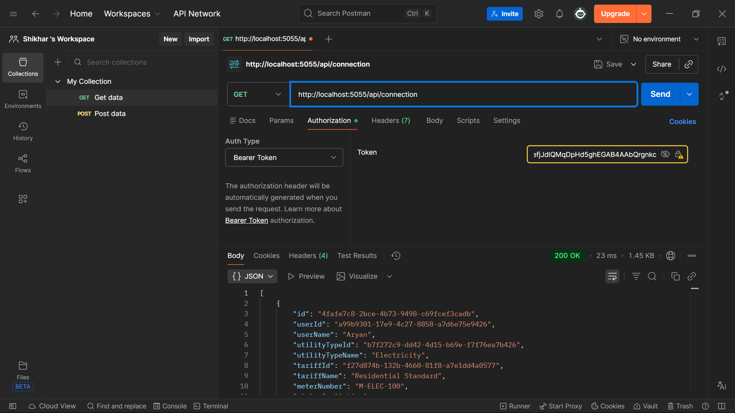

**Billing Officer**

1. Billing officer can’t access connection which is admin functionality

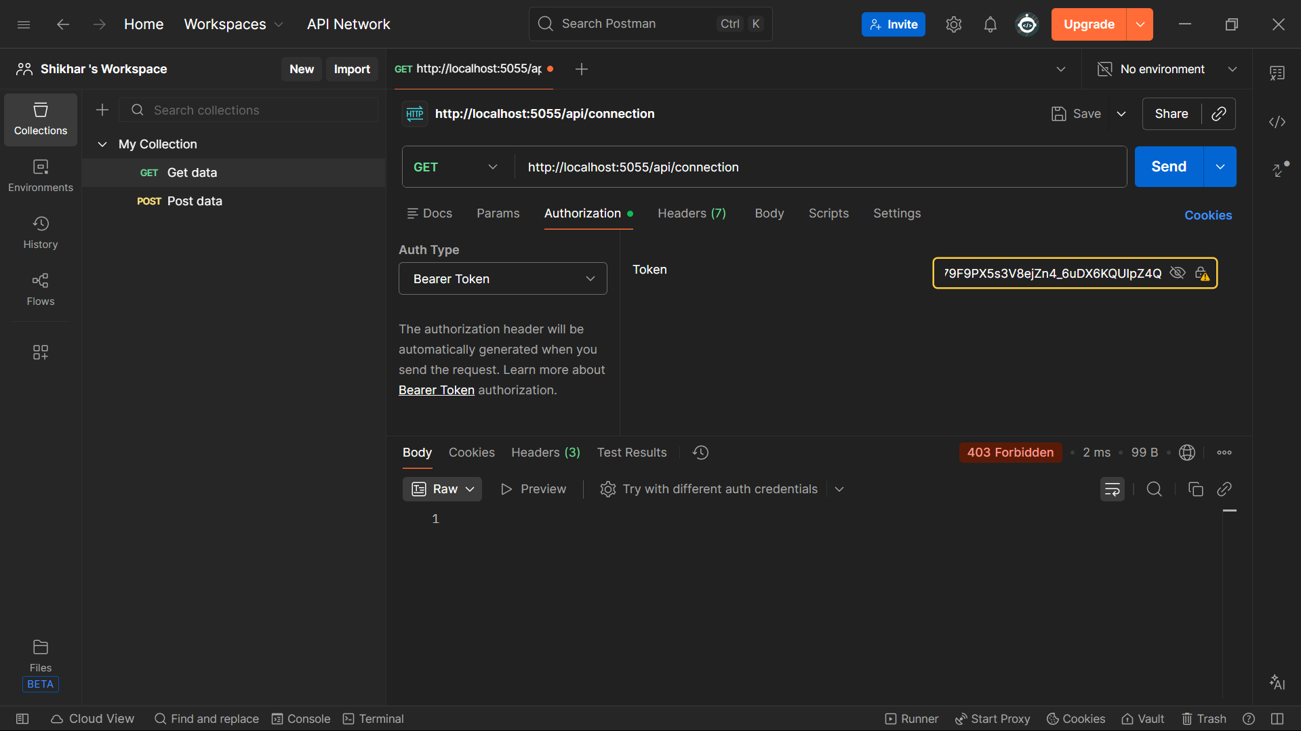

2. Billing officer cant access users notification

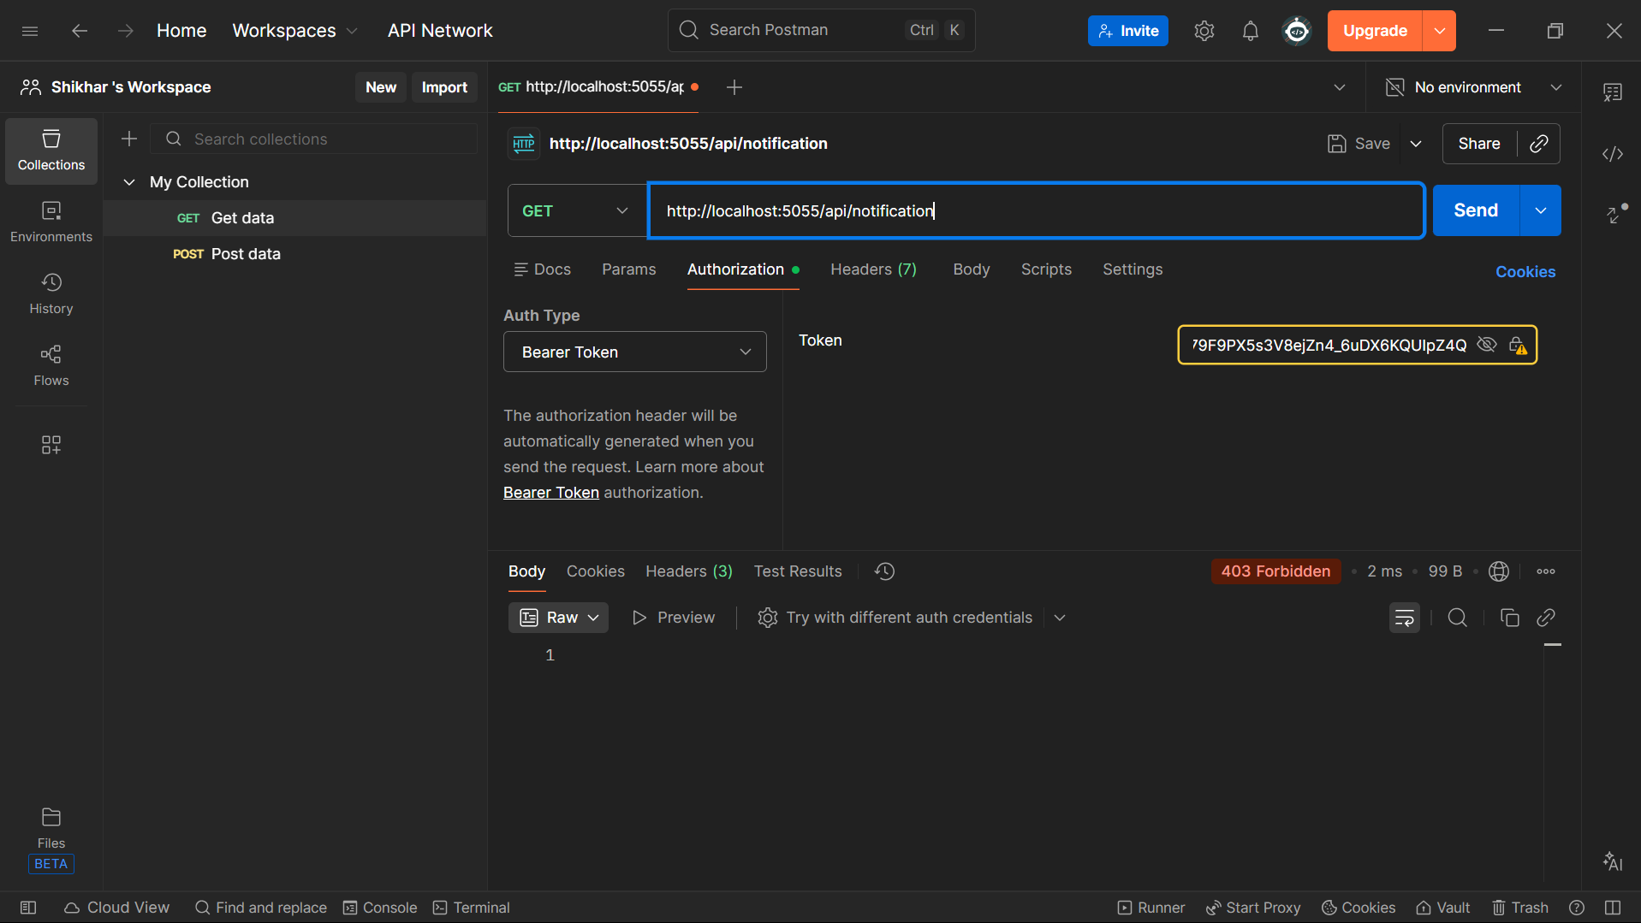

3. Billing officer cant access Consumption reports which is Account Officer only

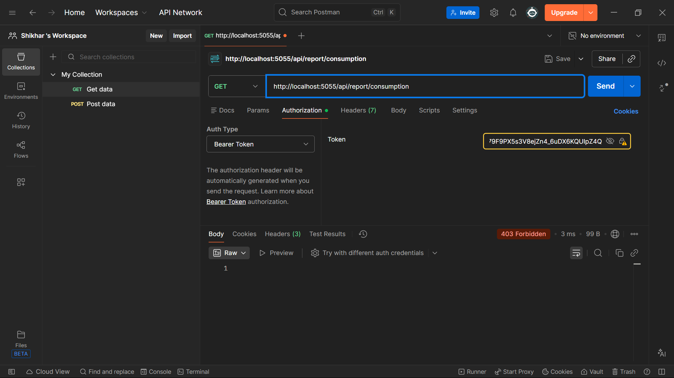

4. Billing officer can access current meter readings

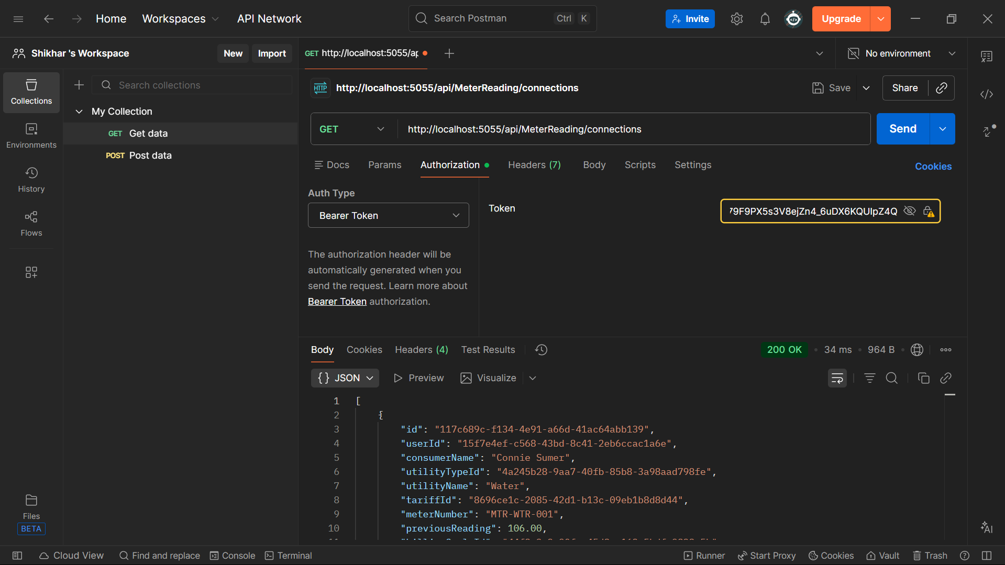

**Account Officer**

1. Account Officer can’t create Users since that is admin functionality

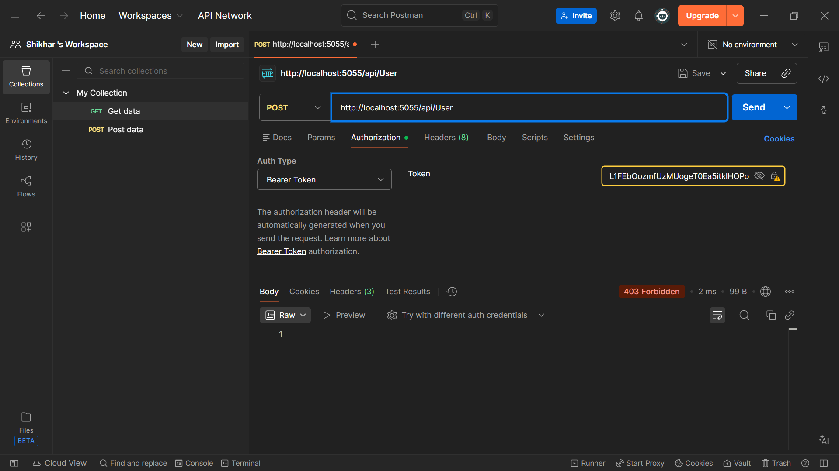

2. Account Officer can’t access notifications since that is Customer only

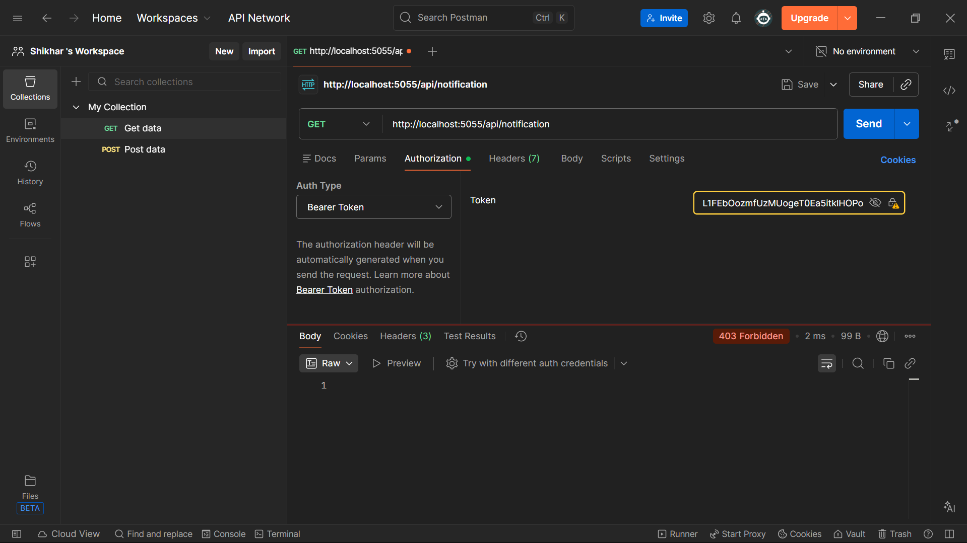

3. Account officer can access outstanding bills

